On a higher level

Coneo High by Scheurich

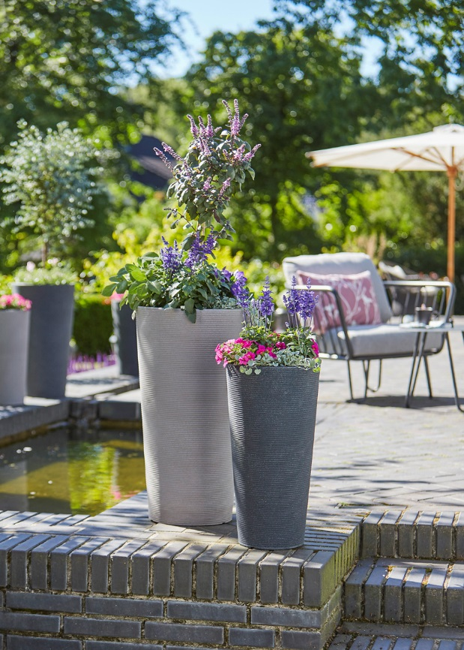
Authentic and modern; Scheurich stands for consistent design and thoughtful development of products. Currently, the company is allowing the elegant Coneo containers to grow upwards, with the addition of Coneo High, new to this range and available in two tall container sizes and in two colours, Black-Granite and Taupe-Granite.

Scheurich started this range of plant containers in five earth and stone shades which made arranging outdoor planters fun - the natural colour scheme contrasts nicely with the conical grooved shape of the container. Time to move up! The tall containers can be combined attractively with the other available products in the Coneo family. Perfect plant partners are, for example; Dichondra argentea ‘Silver Falls’, salvia and miniature petunias. These newcomers are really eye-catching on doorsteps, but also on balconies, patios or in gardens.

The Coneo High containers have an insert which enables easy planting, there is a drainage hole which can be closed with a plug. The quality of the characteristic natural styling of the pot’s surface is not in doubt; it has been manufactured with a sophisticated rotation-moulding process and uses high-value plastic - and of course because of the quality label “Made in Germany”.

Available Sizes:
Coneo: 30, 40 and 49 cm
Coneo High: 55 and 70 cm

