Original structures

Corteza by Scheurich
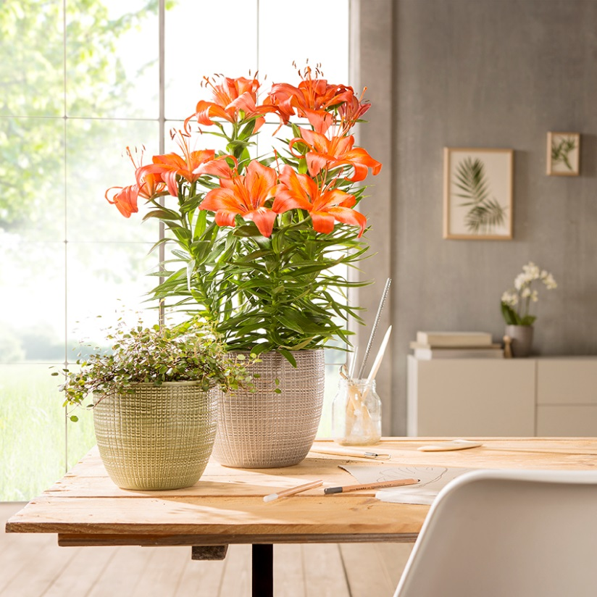
Getting outdoors is part of the personal work-life balance for many city dwellers. Scheurich’s new cover-pot range, Corteza, embodies a short escape from the daily routine. The crafted appearance of its surface represents the trend towards nature and offers a small visual break from laptop, mobile phone and TV.

Getting creative is the motto for our personal lives and our surroundings. Products with a handmade look are therefore moving into our homes just as much as nature’s stones, sand and wood, which are often used indoors in decorative arrangements. Corteza’s design is based on fabric patterns; the exterior surface resembles coarse linen and is inviting to the touch, whilst the grooved finish gives it an iridescent look. Available in the decorative colours of Menta, Canela, Pimienta, Vainilla and Panna.

The upper part of the container wall is thicker which emphasises its quality and reinforces its crafted appearance. In contrast, tender lily plants or small leafed maidenhair pair up wonderfully with these absolutely watertight ceramic containers which are made in Germany.

Orchids are symbols of natural perfection. The Corteza range also includes orchid pots - because the balance of opposites is essential in life for so many.

Available Sizes:
Cover pots: 14, 16, 19, 22 and 25 cm
Orchid pot: 15 cm

