A summer dream

Country Star by Scheurich

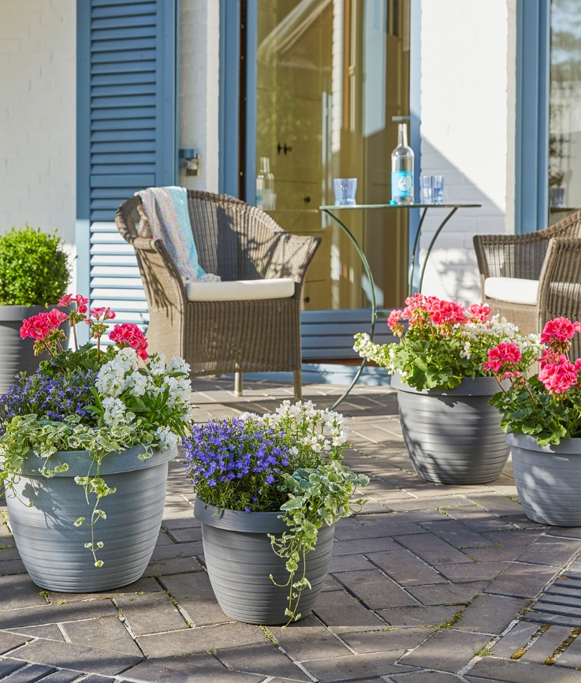
City, countryside, charisma! Scheurich adds another container to the popular Country Star range - Granite Grey. With its authentic stone-effect styling it offers the ideal framework for the creation of some country flair in the garden. Plants such as geranium, lobelia and matthiola used in combination, present a cheerful sight when combined with Country Star’s natural presence.

A lineup of stars! After Terracotta, Living Taupe and Metallic Grey, Granite Grey is another “natural beauty” for the outdoor space. The prominent rim is both eye-catching and functional; irrespective of the chosen size, these high-quality plastic containers can be handled safely and relocated easily even when planted. The circular grooves that taper towards the base make you think “handmade”, yet without any loss of their urban glamour. Depending on the position of the sun, the grooves and ridges create subtle iridescent effects as well as a sense of light and shade.

When it comes to manufacturing, these are made in Germany, so as you would expect, every practical detail has been thought through. Three drainage holes and a small water reservoir are a real plus to enable healthy plant growth.
The various Country Stars can be arranged to create a multitude of different planting displays; Strawflowers and small tomato plants, as well as nasturtiums and santolina will let you dream of the countryside within the city.

Available Sizes:
25, 30, 35, 40 and 48 cm

