Gem for apartments

Mirror Silver by Scheurich

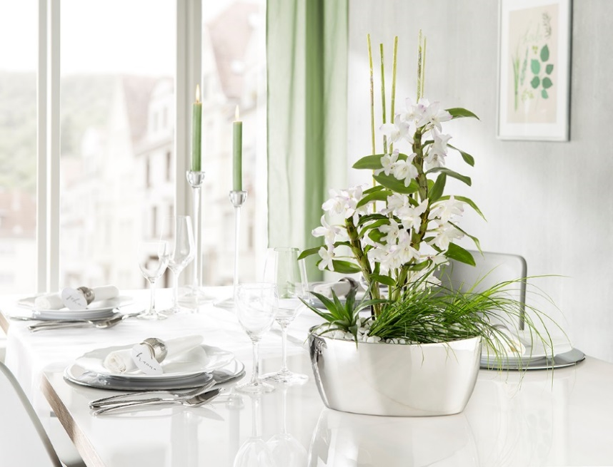
Orchids are eye-catching! No matter where, be it on sideboards or dining tables, the blossoms of these decorative plants draw all the attention. Now Scheurich brings new glamour into homes with its new Mirror Silver bowls and further refines the appearance of these exotic beauties.

Parents, friends and colleagues will also be delighted as this oval bowl, planted with orchids, shrubs and spider plant, makes a sophisticated present for any host. Mirror Silver also shines when decorated with elegant stems or - in the round version - with three medium orchids, and quite literally brings the sunshine indoors by reflecting the light.

Exclusivity for the queen of plants; Mirror Silver has an authentic mirror effect which can be further enhanced with the right table setting; quality cutlery, glass and china reflect elegantly in the mirrored sheen of the plant bowl.

Scheurich additionally offers a large range of cover pots and orchid containers in Mirror Silver - dendrobium, phalaenopsis and many other plants will find their new favourite spots.

Available Sizes:
Round plant bowl: 24 cm
Oval plant bowl: 28 cm

