Tradition revamped

Mosaic by Scheurich

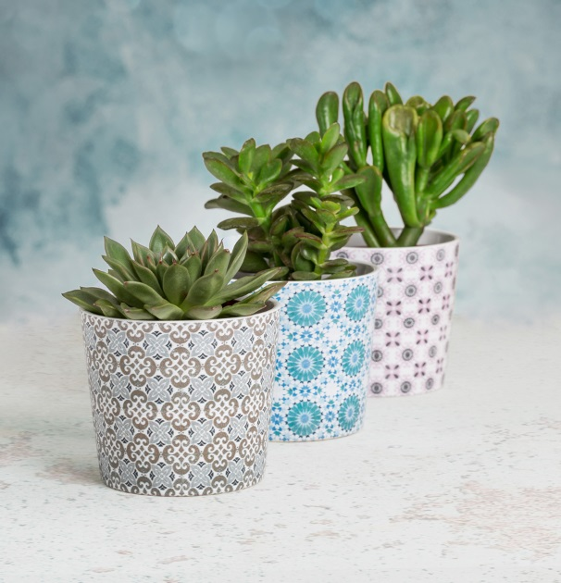
Welcome back! Ceramic tiles are back, front and centre stage as an interior design style, something we want to see more of in the future. These traditional mosaic patterns are not only part of our kitchens, bathrooms and our comfy cafés, but also feature on wallpapers, cushions or cover-pots such as Scheurich’s Almeria, Malaga and Granada.

And they have many stories to tell - of grand mansions, the Alhambra or old manufacturing sites. The range Mosaic is versatile and plant lovers can mix and match them to find their individual style; combined with plants such as Echeveria or Crassula, Almeria, Malaga and Granada fit in wonderfully with vintage furniture, plain coloured cover-pots or interior accessories in lush blue or red hues. Create your own story – a happy outcome is guaranteed and of course all mosaic cover-pots are 100 percent waterproof.

The shabby chic look of Almeria, Malaga and Granada brings back memories of holidays in Spain, Portugal and around the Mediterranean. To retain this feeling at home, simply place an orchid into the stylish orchid pot with its border and white base; it all goes to prove that tradition and trend work well as a dream team.

Available Sizes:
Coverpots: 11, 13 and 15 cm
Orchid pot: 14 cm

