A Mass of Flowers

Burgundy Rose by Scheurich
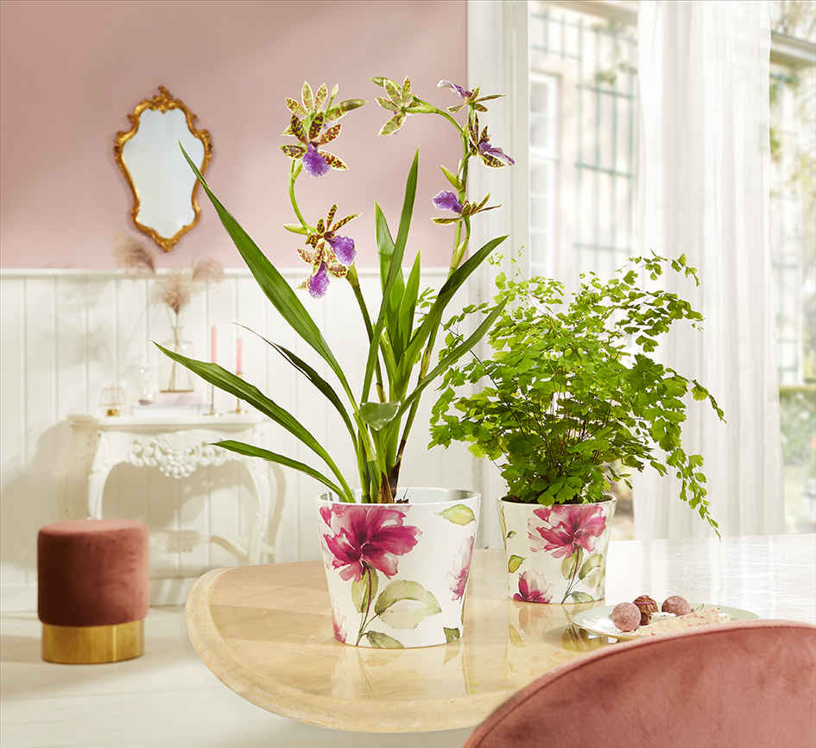
Welcome to the cosy cottage! Scheurich presents Burgundy Rose, a beautiful rose garden in the middle of our living rooms, transporting the charm of luxurious English cottages into a new season. The unique and graceful rose design with its soft fabric look spreads across the white pot surface and tells of stories of love and longing.

This on-trend nostalgic style can be found across the world of décor; in designs for cushions and curtains, as rose coloured wall paint and in wallpaper decorated with flower blossoms or dreamy designs in pastel shades. Combined with solid-coloured cover-pots in Oliva, Taupe, Panna or Burgundy, the look of sophisticated cosiness is complete. This stylish look becomes even more homely when combined with family heirlooms and nick-nacks; porcelain dishes with rose designs or chandeliers with flower shaped details are popular accessories and guarantee to enhance the display.

Combined with a maidenhair fern (Adiantum capillus-veneris) or an orchid Zygopetalum Burgundy Rose is perfect for the dressing table in a bathroom or bedroom. A large mirror with an ornate gold frame perfectly finishes off the theme and visually expands this little interior rose garden. Wild, soft and realistic - Scheurich creates a contemporary scene for the classic rose and provides a strong centrepiece for this floral trend.

It’s as clear as day, Burgundy Rose guarantees the quality features of “Made in Germany” and “100 percent waterproof”.

Available Sizes:
11, 13, 15 and 17 cm

About Scheurich

My pot. My style.
Scheurich knows how to meet different customer demands and to offer fashionable products for current trends in interior styles. With designs at the pulse of the time, proven quality Made in Germany and one of the largest offerings of shapes in the market, the family business is the No. 1 in Europe when it comes to plant containers for the in- and the outdoors. The sustainable ceramics and plastics production lines at both German locations make Scheurich a pioneer of environmental protection.

