Fantastic Colour Mix

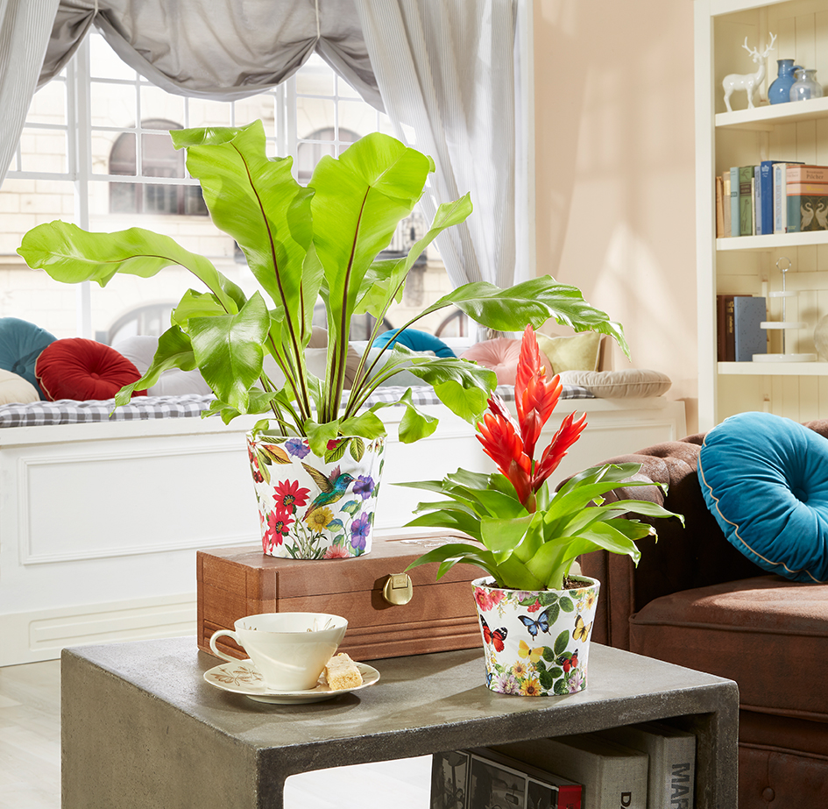
Paradise and Tropicana by Scheurich

It’s getting colourful in the urban jungle! Flowers, fruit, leaves and animals dance around Scheurich’s cover-pots Paradise and Tropicana and bring even more life into the home jungle. Exotic, extravagant and eye-catching - Paradise and Tropicana are expressive designs full of nature’s vibrancy.

Amidst the calmness of bird’s nest fern (Asplenium nidus), Vriesa “Madonna” and other plants, beautiful design details can be found; the blue moth is gathering with magnificent butterflies on Paradise, a humming bird is fluttering between red, yellow and purple blossoms in Tropicana.. Strong colours, large designs and a glossy white finish to the pots emphasise the presence of Paradise and Tropicana in the home. Fine shadows additionally create an appearance of depth to the design and give the pots a realistic impression.

Everyone who likes to mix colours and patterns will love these opulent designs and can combine Paradise and Tropicana with solid-coloured cover-pots in Burgundy, Oliva and Panna. Interior decoration enthusiasts can also add colourful prints, books or cushions in rich hues next to the plants to maximise the dramatic effect of the colours.

The quality features “Made in Germany” and “100 percent waterproof” guarantee clear benefits.

Available Sizes:
Tropicana: 11, 13, 15 and 17 cm
Paradise: 11 and 13 cm

About Scheurich

My pot. My style.
Scheurich knows how to meet different customer demands and to offer fashionable products for current trends in interior styles. With designs at the pulse of the time, proven quality Made in Germany and one of the largest offerings of shapes in the market, the family business is the No. 1 in Europe when it comes to plant containers for the in- and the outdoors. The sustainable ceramics and plastics production lines at both German locations make Scheurich a pioneer of environmental protection.

