Love is in the Air

Orchid pots by Scheurich

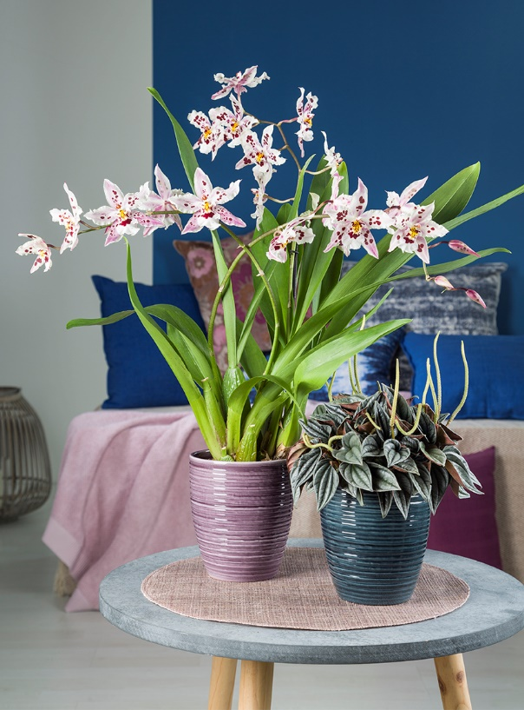
Like a tale from “1001 Nights” and yet familiar: Orchids are among the most popular houseplants for living spaces and their cascade of blooms stands out impressively up against other plants. If orchids make you think of divas, you might be surprised. These cosmopolitan plants require lower maintenance than you might imagine. Orchids only need a quick watering once a week and a careful dose of fertiliser, plus they love to have their roots in the air!

Scheurich has been an expert on orchid pots for years and this new series features precisely sized ceramic cover pots named Glass Malva, Glass Petrol and Glass Olive for Odontonia, Beallara or any of the other numerous types of orchid. If you love orchids, you probably love details, and Scheurich shows a real eye for detail with these newcomers. The ridged surface appears to shimmer like glass as it reflects the light from its surroundings and helps to emphasise the elegant charm of the orchids.

For all three Glass variants the classic image of orchid and plant pots merges with current interior design trends; a perfect pairing of the organic with the feel of ‘hand-made’ styling. A beautiful scene can be created by adding accessories such as a placemat of a complementing colour.

A practical plus: Thanks to the generously sized shape, the aerial roots have no contact with water and the plants can develop naturally. These innovations are Made in Germany, from 100% watertight ceramics.

Available sizes:
Orchid pot 669 Glass Malva, Glass Petrol,
Glass Olive: 14 cm

About Scheurich

My pot. My style.
Scheurich knows how to meet different customer demands and to offer fashionable products for current trends in interior styles. With designs at the pulse of the time, proven quality Made in Germany and one of the largest offerings of shapes in the market, the family business is the No. 1 in Europe when it comes to plant containers for the in- and the outdoors. The sustainable ceramics and plastics production lines at both German locations make Scheurich a pioneer of environmental protection.

