Ethnic Look

Fashionista by Scheurich

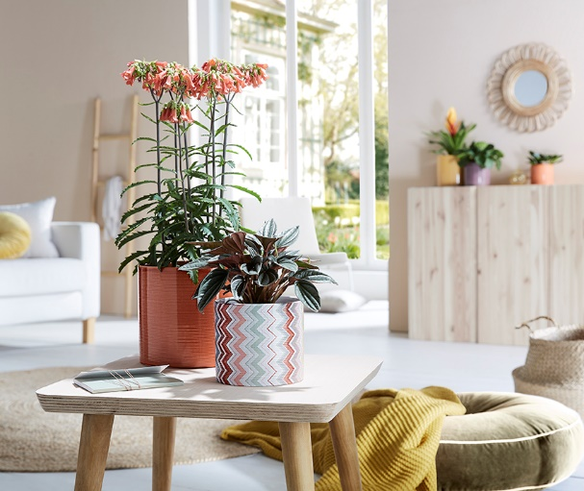
Scheurich presents another prime example of couture for plants. The new series Fashionista, features a simple, cylindrical shape, which provides space for the beautiful zigzag design. From the catwalk to the window sill - Fashionista attracts the eye with its trendy charm and inspires one to seek out expressive décor in warm colours.

Beautiful colours include Papaya. Combined with a tall growing Kalanchoe (Lucky Bells), this cover-pot picks up the orange elements of Fashionista and transforms the two into a duo that will make you go ‘wow’. Another eye-catching arrangement can be achieved by using this newcomer with the Sesame and Panna colours. There is always movement; Fashionista makes a vivid entry thanks to its grooved surface and smoothly snatches the top spot away from other decorative accessories. Trendsetters use a pepper plant (Peperomia rosso) to create an intentional contrast to the soft lines of the pattern.

Keep the ambience of homes visually on the ball with this colourful quartet: arranged in a row or grouped, Fashionista along with Aubergine, Papaya and Zabaione, brings an air of Milano, New York or Berlin into the home. Very down to earth is its quality standard; Fashionista is ceramic, Made in Germany and 100% watertight.

Available sizes:
Cover pots 828 Aubergine, Zabaione:
12, 14, 16 and 19 cm
Cover pots 828 Papaya:
12, 14, 16, 19, 23 and 28 cm
Cover pots 828 Fashionista:
12, 14, 16 and 19 cm

About Scheurich

My pot. My style.
Scheurich knows how to meet different customer demands and to offer fashionable products for current trends in interior styling. With its fingers on the pulse of design, proven quality ‘Made in Germany’ and one of the largest offerings of shapes in the market, the family business is No. 1 in Europe when it comes to plant containers for both the indoors and out. The sustainable ceramics and plastics production lines at both German locations make Scheurich a pioneer of environmental protection.

