Stylish with Stones

Stone Look by Scheurich
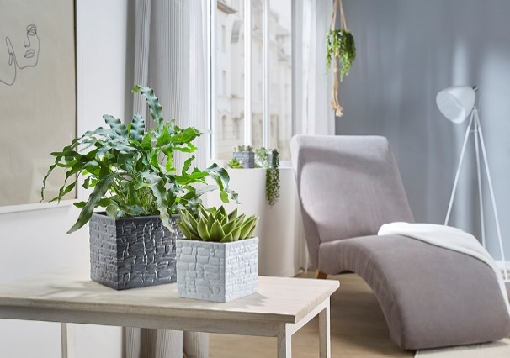
Great inspiration! Renovated stone houses are rightly associated with comfort and a calming atmosphere. Scheurich is now bringing this cosy cottage feeling directly into the living space with its latest cover pot series Stone Look. Chalk, Rock and Slate complete the indoor jungle with their high-quality stone effect design and meet the desire for more naturalness.

Solo, duo or trio; plant enthusiasts can use the three colours according to their personal preferences – on their own or in combination – and may like to choose plants such as echeveria or golden polygody (Phlebodium). In the lighter shades of stone, the surface texture and indentations seem especially realistic. Stone Look is produced using a sophisticated casting technology, whereby Scheurich marries its knowledge of craftsmanship with innovative techniques. The cover pots are ceramic and are 100% watertight and Made in Germany.

The authentic styling is reinforced by the cubic shape of the cover pots. The clear lines are counterbalanced with the textured surface, making Stone Look seem cooler or warmer depending on the angle of the light, hence creating a harmonious bigger picture.

Available sizes:
Cover pots: 11, 13, 15 and 18 cm

About Scheurich

My pot. My style.

Scheurich knows how to meet different customer demands and to offer fashionable products for current trends in interior styling. With its fingers on the pulse of design, proven quality ‘Made in Germany’ and one of the largest offerings of shapes in the market, the family business is No. 1 in Europe when it comes to plant containers for both the indoors and out. The sustainable ceramics and plastics production lines at both German locations make Scheurich a pioneer of environmental protection.

