Naturally elegant!

Lineo by Scheurich

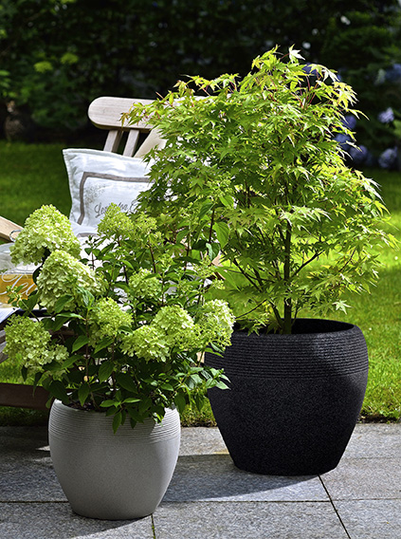
Attractively designed, sustainably produced, comfortable to use - Lineo by Scheurich is the ideal all-rounder. These high-quality planters with their subtle surface relief offer a natural look in Black-Granite and Taupe-Granite colour options. Lineo suits classic patios with wooden decking just as well as modern styled balconies or winter gardens and rattan furniture. The innovative colour concept, combined with a craftsmanlike natural charm, complements the product range and harmonises with outdoor living style and a classical garden atmosphere.

Nobody would guess it at first glance, but these smoothly curved plant containers are easy-to-carry lightweights! Manufactured using a sophisticated rotation-moulding technique and partly consisting of recycled plastic, the planters give the appearance of being made of authentic natural materials. The Lineo series, as you’d expect, is the result of quality production methods and is an original product Made in Germany.

The Lineo containers are suitable for both indoor and outdoor use, because they have the practical built-in lock, first developed by Scheurich, which allows excess water to run off in the summer and prevents damage to flooring when they are brought in over winter. Hardy potted plants like Hydrangeas and Japanese maples, as well as Hibiscus (Hibiscus rosa-sinensis) and other exotic beauties, are perfectly at home in these frost and UV-light resistant containers. It only takes a tweak to remove the tightly fitting plug and bring it into the “parking position” when it’s time for these plants to move back outside.

Available Sizes:
30, 40 and 48 cm

About Scheurich

My pot. My style.
Scheurich knows how to meet different customer demands and to offer fashionable products for current trends in interior styling. With its fingers on the pulse of design, proven quality ‘Made in Germany’ and one of the largest offerings of shapes in the market, the family business is No. 1 in Europe when it comes to plant containers for both the indoors and out. The sustainable ceramics and plastics production lines at both German locations make Scheurich a pioneer in environmental protection.

