Lifestyle and Authenticity

No.1 Stone by Scheurich

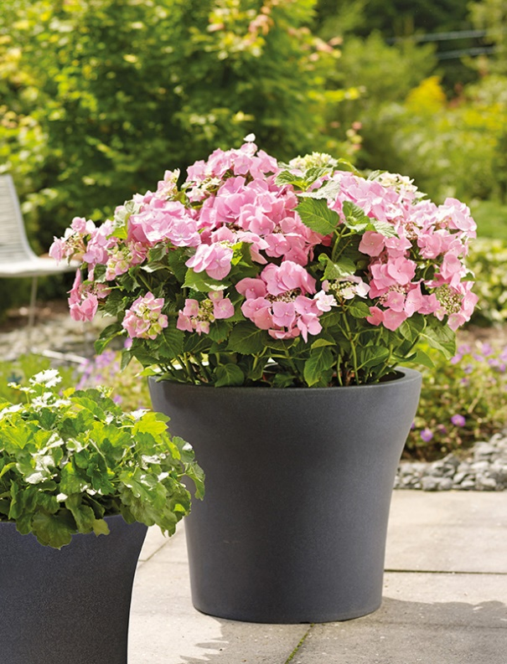
Successful design is everywhere; a fact made evident yet again with the world’s favourite planter shape by Scheurich and used in the company’s new outdoor series No.1. This lightweight plastic planter is designed to impress with its clear contours, capturing both a balanced and a modern feel. Absolutely on-trend is the thick-walled profile and the natural surfaces, which are both quality features of No.1 Stone.

Sturdy materials and thoughtful design are important indicators of durability and ease-of-use when it comes to outdoor products. That’s why only frost-proof and UV-resistant plastics meet the Scheurich standard. No.1 Stone is manufactured in Germany, using the elaborate rotation-moulding technique. The large drainage opening in the base prevents water logging in the container, due to heavy rain for example. The plug is especially innovative; it can be used to completely seal the drainage opening when moving the planters indoors. While not in use, the plug can be stored in a ‘parking slot’ in the base and is therefore always at hand when needed.

No.1 Stone is available in authentic Black Granite colour and is especially suitable for modern outdoor living and dining areas. To be able to place these pots flexibly inside and out, luscious flowering plants like hydrangea, Mediterranean potted plants such as small olive trees, exotic citrus plants like Kumquats (Fortunella), or bay laurel (Laurus nobilis) are ideal partners. The XL edition of No.1 even offers enough root space for potted woody plants such as Japanese Maples.

Available Sizes:
Planters: 30, 40, 48 and 60 cm

About Scheurich

My pot. My style.
Scheurich knows how to meet different customer demands and to offer fashionable products for current trends in interior styling. With its fingers on the pulse of design, proven quality ‘Made in Germany’ and one of the largest offerings of shapes in the market, the family business is No. 1 in Europe when it comes to plant containers for both the indoors and out. The sustainable ceramics and plastics production lines at both German locations make Scheurich a pioneer in environmental protection.

