Garden Feeling

No.1 Style by Scheurich

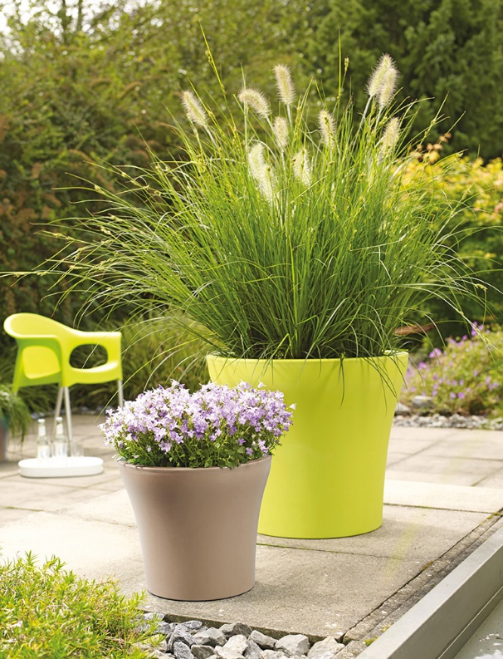
The outdoor design series No.1 has been based on the world’s most successful planter shape, by Scheurich, whose clear lines have already made it an indoor classic. That this favourite is absolutely ready for the outdoors, is not just due to its sturdy walls and modern colour concept. The materials used and its functional design integrate this series seamlessly into Scheurich’s family of high quality outdoor products; frost-proof, extremely light, and UV resistant plastic planters which are ’Made in Germany’.

One of No.1 Style’s many sophisticated details is its ingenious plug which can be safely stored underneath the container by setting it to the ’parking position‘ when it’s not needed outdoors. If the planter is moved indoors, this plug is used to close the drainage hole quickly and easily, making it absolutely leak-free. This ensures No.1 Style is an invaluable planter both indoors and out. Additionally, Scheurich’s double-rimmed design facilitates cleaning and repotting; the inner rim can be taken off, making it possible to extract the root ball and easily remove the soil.

No.1 Style is available in three colours; Pure Lime, Living Taupe and Metallic Grey. They co-ordinate well and in harmony with each other, creating new, eye-catching accents in any landscaping design. The colour palette has been selected to perfectly complement colourful bell flowers (Campanula), heathers (Erica) and other summer and autumn flowers. Nicely contrasting arrangements can be achieved with perennial grasses like silver grass (Miscanthus), fountain grass (Pennisetum), or ornamental foliage plants such as alumroot (Heuchera). These versatile planters are also ideal partners for Mediterranean potted plants like rose mallow (Hibiscus), oleander (Nerium), citruses (Citrus) and fan palm (Brahea), which move indoors during the winter.

Available Sizes:
Planters: 30, 35, 40 and 48 cm
Tall containers: 32 and 43 cm

About Scheurich

My pot. My style.
Scheurich knows how to meet different customer demands and to offer fashionable products for current trends in interior styling. With its fingers on the pulse of design, proven quality ‘Made in Germany’ and one of the largest offerings of shapes in the market, the family business is No. 1 in Europe when it comes to plant containers for both the indoors and out. The sustainable ceramics and plastics production lines at both German locations make Scheurich a pioneer in environmental protection.

