Wave of Success

Wave Globe Slim by Scheurich

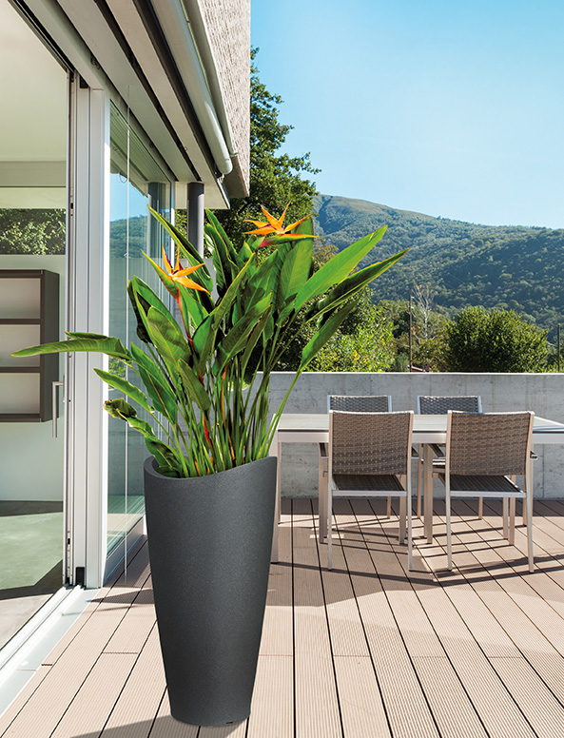
This range of elegant lightweight planters continues its success story. There are now 12 different shapes whose curved designs and authentic looking surfaces can be used in combination perfectly. High-quality manufacturing, functional features, and a large variety to choose from, for indoors and outdoors, are trademarks of the Wave Globe range. There’s just the right design and shape for every plant aficionado.

Wave Globe Slim is among the latest additions to the family. These slender and tall containers suit a multitude of locations; they are an attractive addition not just for outdoor areas, but also for living spaces and house entrances. No matter the location, the containers don’t take up a lot of space due to their slim shape. Like all other planters in the range, Slim has an integrated water-drainage plug, this time located in the container wall. The plug is placed in the “parking position” and prevents waterlogging when in use. These planters can therefore also be used on sensitive flooring.

Wave Globe Slim makes a versatile design feature for patios, helping to create a beautiful and natural atmosphere. The granite look of the surface is shown at its best in Black colour. In fact, this is a sustainably recyclable plastic planter, manufactured with a sophisticated rotation-molding technique. This makes Slim easy to transport and placement around the home and garden can be easily changed. An opening in the base which can be filled with sand or gravel increases stability. A strainer ensures that water runs off this ballast when it is used in the container.

Planting is simple: the thoughtfully designed insert offers space for a diverse mix of plants. Rushes are year-round eye-catchers, olive trees bring the charm of the Mediterranean onto the patio, and - for indoors - greenery like Zamioculcas or Sanseveria cut a fine figure.

Available Size:
Wave Globe Slim: 80 cm

About Scheurich

My pot. My style.
Scheurich knows how to meet different customer demands and to offer fashionable products for current trends in interior styling. With its fingers on the pulse of design, proven quality ‘Made in Germany’ and one of the largest offerings of shapes in the market, the family business is No. 1 in Europe when it comes to plant containers for both the indoors and out. The sustainable ceramics and plastics production lines at both German locations make Scheurich a pioneer in environmental protection.

