Extra for orchids

Paradise by Scheurich
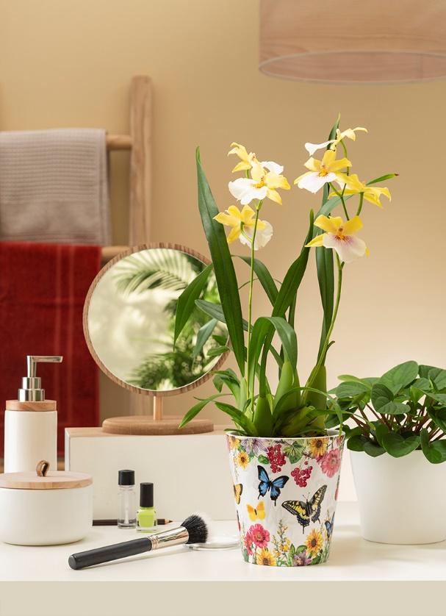
High on blossoms! Colourful summer flowers and berries decorate the new orchid pot by Scheurich which is part of the Paradise range. They create a sea of flowers that even beautiful butterflies will enjoy when combined with Miltonia orchids (Miltonia Sunset).

The phrase “Colourful Mix” exemplifies these ceramic cover pots, they are perfect for the home and exude an exotic flair especially in combination with their natural partner, the orchid. Coordinated with other cover pots in the on-trend colour Curcuma - embodying “spice up your life” - they provide an expressive display. If you prefer more low-key colour combinations, a solid coloured cover pot in Panna for example, paired with a peperomia (Peperomia Napoli) is the way to go.

Soft shadows emphasise the realistic look of the shining blossoms and butterflies within the design. The large pattern has no trouble competing with impressive orchid flowers and together they create a harmonious feature on side tables and sideboards.

The tropical beauties are well cared for in the tall orchid pot. A little step on the inside prevents waterlogging, making sure that the sensitive aerial roots don’t drown. For the Paradise series, as always, Scheurich guarantees the pots are watertight and benefit from the Made in Germany quality that you’re used to.

Available sizes:
Orchid container: 14 cm
Cover pots: 11 and 13 cm

About Scheurich

My pot. My style.
Scheurich knows how to meet different customer demands and to offer fashionable products for current trends in interior styling. With its fingers on the pulse of design, proven quality ‘Made in Germany’ and one of the largest offerings of shapes in the market, the family business is No. 1 in Europe when it comes to plant containers for both the indoors and out. The sustainable ceramics and plastics production lines at both German locations make Scheurich a pioneer in environmental protection.

