Next Level

Plant Up by Scheurich
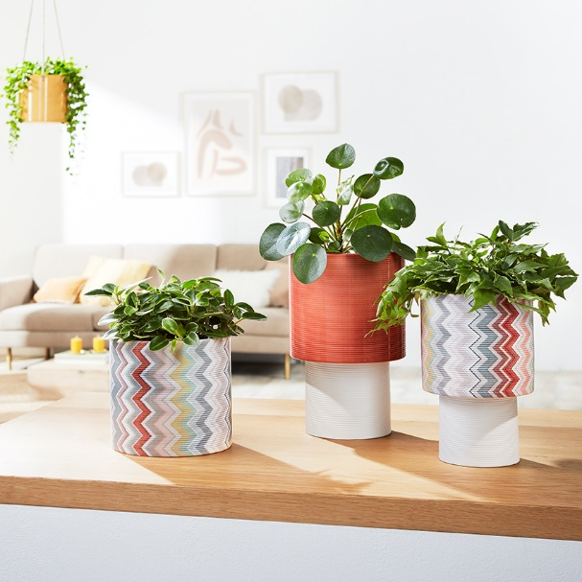
Plants are present on all levels of our living spaces. Scheurich is levelling up the house fern, Money tree or mini Monstera with its series Plant Up. These stylish cover pots now come with a pedestal. Fashionista, Panna and Papaya attract all the attention on shelves, tables and benches and represent a new trend in innovative planter design.

Really cool in shape and warm in colour - Plant Up has everything a decorative accessory needs. The attractive ridged surface of Plant Up catches the light and helps to show it off at its best, making it an attractive feature in living or bedrooms. Fashionista is at the heart with its nod to Italian fashion design, while Panna and Papaya frame Fashionista in colour. The white pedestal gives Plant Up a lift and a lightness of design that allows favourite plants to surpass themselves.

Placed on trays, shelves or multi-level furniture, Crassula or Flaming Katy take their place in the home in a charming way, becoming an important part of a holistic interior design concept.

The same ridged surface finish of Plant Up is also used for cover and hanging pots by Scheurich, which opens up wonderful possibilities for combinations.

Plant Up is Made in Germany and 100% watertight.

Available sizes:
Panna: 22 and 25 cm
Fashionista: 22 cm
Papaya: 25 cm

About Scheurich

My pot. My style.
Scheurich knows how to meet different customer demands and to offer fashionable products for current trends in interior styling. With its fingers on the pulse of design, proven quality ‘Made in Germany’ and one of the largest offerings of shapes in the market, the family business is No. 1 in Europe when it comes to plant containers for both the indoors and out. The sustainable ceramics and plastics production lines at both German locations make Scheurich a pioneer in environmental protection.

