Grooves in prime shape

Groove by Scheurich
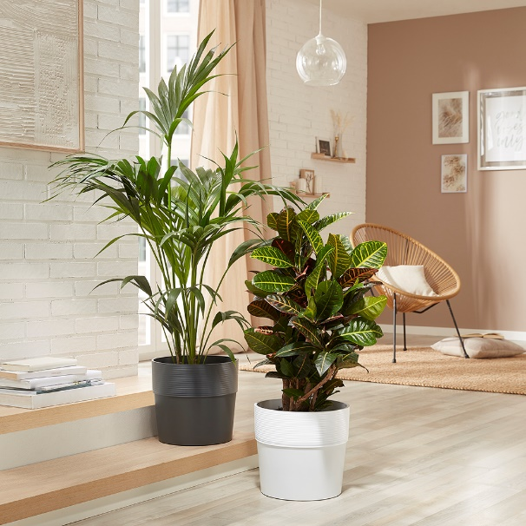
Here comes a new prime example of sustainable, interior design styling: Groove shows off a modern grooved finish in a striking design and is made from the recyclable plastic Certuro. The thick walled cover pot makes an eye-catching statement in any living space that can be highlighted even further with XL plants such as the Kenia palm tree (Howea forsteriana) or Croton (fire croton).

Naturally beautiful interior design relies on well co-ordinated colour concepts. Warm, soft colours for upholstered furniture, curtains and walls are popular and Groove enhances these comfortable living spaces with characteristic flair in the colours of Avorio, Bianco and Nero.

Interior décor fans can choose between combining several Groove pots of the same colour or mixing and matching all three colours. Indeed Groove looks especially appealing as a duo or a trio. Just as attractive is the material: Scheurich uses an innovative multicomponent technology to manufacture Certuro - a high quality plastic with a high percentage of recycled material, 8 year warranty and the quality seal “Made in Germany”.

With Groove’s holistic design, Scheurich demonstrates it has its fingers on the pulse. Moving from living rooms to the garden or patio, you will immediately recognise the matching outdoor version. Groove+ has a watering plug insert and a drain off system and continues the indoor style in Concrete, Carbon, Mahogany and Walnut colours.

Available sizes:
30 cm

About Scheurich

My pot. My style.
Scheurich knows how to meet different customer demands and to offer fashionable products for current trends in interior styling. With its fingers on the pulse of design, proven quality ‘Made in Germany’ and one of the largest offerings of shapes in the market, the family business is No. 1 in Europe when it comes to plant containers for both the indoors and out. The sustainable ceramics and plastics production lines at both German locations make Scheurich a pioneer of environmental protection.

