Chic and clever

Copa XXL by Scheurich
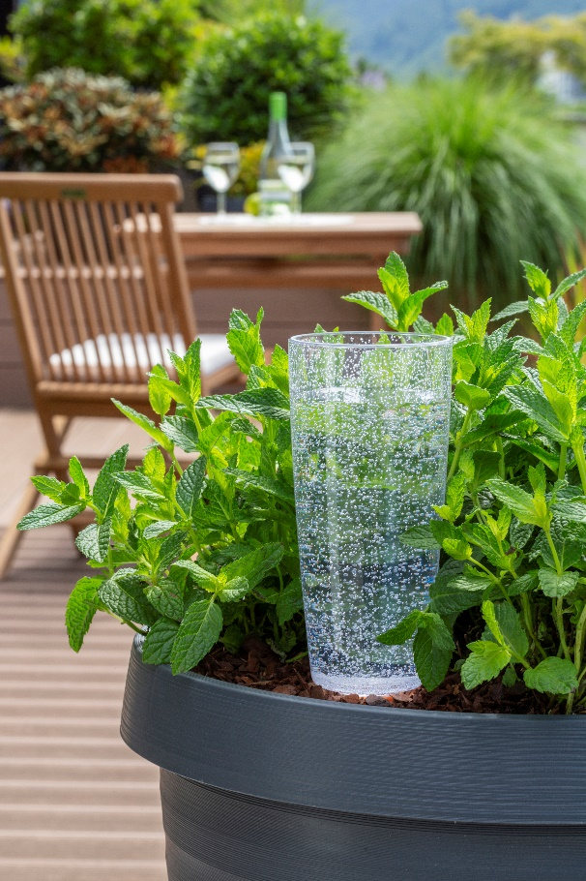
The next holiday is a given! Anticipation increases as plans develop for the best weeks of the year. Who is going to take care of favourite plants on the balcony or patio for example? Scheurich is delivering the best answer with its smart watering concept, Copa XXL. With Copa XXL you can water big plants perfectly for up to 15 days depending on the location, making you completely, or almost entirely, independent of neighbourly help.

Copa XXL is also a great companion day to day, showing off its elegant champagne glass design. With its one litre capacity this handy watering helper constantly drips water into the soil so that the likes of luscious mint plants, Hortensia or foxtail fountain grass can enjoy prolonged periods between watering. This takes a burden off plant enthusiasts busy balancing job, family and hobbies - especially during the hot summer months.

Copa XXL’s clay cone is placed into the moist soil and its reservoir can be filled quite easily just like a glass of champagne, all while looking attractive. The body is made from high quality plastic and is available in either a Transparent/Clear or Green finish, both featuring a delicate sparkling pattern. For consistent styling both indoors and out, Copa is also available in sizes M and XL with water reservoirs of 4 and 11 days respectively. Add Bördy for a fun break in style; the watering reservoir with the charming bird-shape doesn’t make a peep about watering cans and takes over the regular water supply in sizes S, M, XL and XXL. Bördy XL even convinced the jury of the renowned German product testing institute “Stiftung Warentest” and won first in class.

Available sizes:
Copa M: 150 ml
Copa XL: 500 ml
Copa XXL: 1000 ml

About Scheurich

My pot. My style.
Scheurich knows how to meet different customer demands and to offer fashionable products for current trends in interior styling. With its fingers on the pulse of design, proven quality ‘Made in Germany’ and one of the largest offerings of shapes in the market, the family business is No. 1 in Europe when it comes to plant containers for both the indoors and out. The sustainable ceramics and plastics production lines at both German locations make Scheurich a pioneer of environmental protection.

