On-trend concrete look

Riva by Scheurich
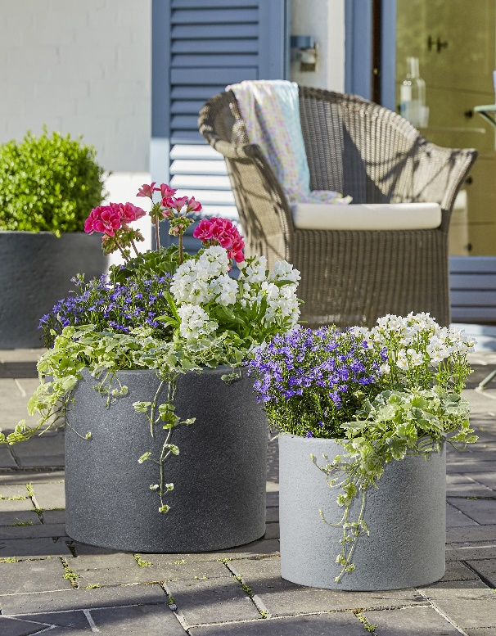
More than ready for the concrete design trend: Scheurich continues this current outdoor lifestyle on the patio, the balcony and in the garden with its new outdoor series Riva. An authentic concrete appearance plus a clean cylindrical design creates the good mood formula for modern private oases.

Young, fresh and classic - all at once: Riva planters in Black Granite and Stony Grey are at the forefront of current styling and perfectly set off flowers and green plants. With a lovely colour palette of pink, blue and white, an eye-catching display is a given for this duo. Upright geranium (Pelargonium zonale) colourful stock (Matthiola incana), edging lobelia (Lobelia erinus) and Frankincense (Plectranthus fruticosus) are perfect, while white Nemesia (hybrids) will add flowery scents in the Stony Grey planter, also decoratively combined with lobelia and Frankincense.

Scheurich provides plenty of creative options with differing sizes as well as elegant tall containers for solitary plants. With frost hardy plants as permanent residents Riva is a perennial attraction.

This innovative series is made from Garduro, a high quality, recyclable plastic with a
10-year guarantee. Made in Germany with a patented rotation moulding technique, these thick-walled containers are especially durable. The high proportion of recycled material emphasises Scheurich’s key priority is sustainability.

Available sizes:
Planters: 30, 40 and 50 cm
Tall containers: 40 and 54 cm

About Scheurich

My pot. My style.
Scheurich knows how to meet different customer demands and to offer fashionable products for current trends in interior styling. With its fingers on the pulse of design, proven quality ‘Made in Germany’ and one of the largest offerings of shapes in the market, the family business is No. 1 in Europe when it comes to plant containers for both the indoors and out. The sustainable ceramics and plastics production lines at both German locations make Scheurich a pioneer in environmental protection.

