Shades of Nature

Cottage by Scheurich
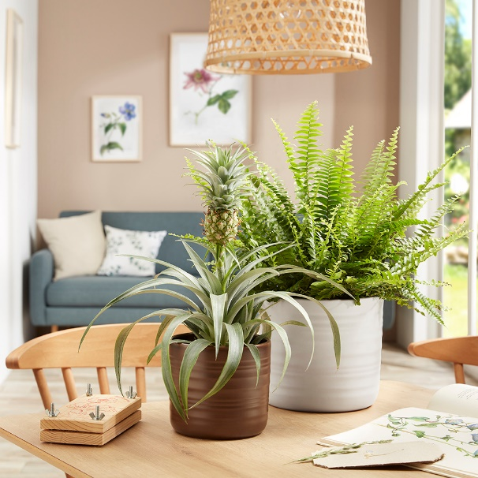
Naturalness is all the rage! And may be seen in many colours. Scheurich now presents the most beautiful subtleties of nature with the series Cottage in the matt colours of Dark Oak, Dry Reed, Soft Wool and Silent Green. The cover pots create a charmingly relaxed atmosphere in the living space and reinforce the desire for sustainability.

Cottage represents the Country Chic decor style for which so many people long. White in all its nuances, as well as beige and sand, are commonly used colours for walls, curtains and tiles with this design trend. Everything is bright, light and cheerful, while creating a framework for interior accessories and furniture using natural materials - this is where individual visual highlights are created. Dark Oak gives an earthy touch for a comfy feel, while Dry Reed, Soft Wool and Silent Green soften the look, bringing a welcoming stylishness into the room.

Because quality of life is defined differently these days: Instead of higher, faster, further, everything in the Cosy Cottage revolves around capturing nature; to find one’s own rhythm, enjoying a little time off or getting creative to find a balance between work and the daily routine. These cover pots are timelessly beautiful, very robust and can be rearranged endlessly.

This design style moves away from perfect lines and lets nature take its course. Cottage features a high quality finish and appears as though crafted on a pottery wheel - this embodies a crafted vibrancy without lacking the reliable quality of industrial manufacturing. Dark Oak, Dry Reed, Soft Wool and Silent Green are 100% waterproof and Made in Germany.

Cottage is especially attractive combined with a mix of contrasting plants. Scheurich combines, for example, Nephrolepis (sword fern), Phlebodium Davana (blue fern) and Phlebodium Aureum (golden polypody) with a beautiful pineapple plant (Bromeliad). Breezy is a favourite, too as Cottage is also available as a hanging pot to bring floral patterns into all areas of the room.

Available sizes:
Cover pots: 12, 14, 17, 20, 23 and 28 cm
Hanging pots: 14 and 17 cm

About Scheurich

My pot. My style.
Scheurich knows how to meet different customer demands and to offer fashionable products for current trends in interior styles. With designs at the pulse of the time, proven quality Made in Germany and one of the largest offerings of shapes in the market, the family business is the No. 1 in Europe when it comes to plant containers for the in- and the outdoors. The sustainable ceramics and plastics production lines at the German locations make Scheurich a pioneer of environmental protection. The company is part of the Scheurich-Group and will be carbon neutral in its plants by 2035.

