A breeze of style

Seaside by Scheurich

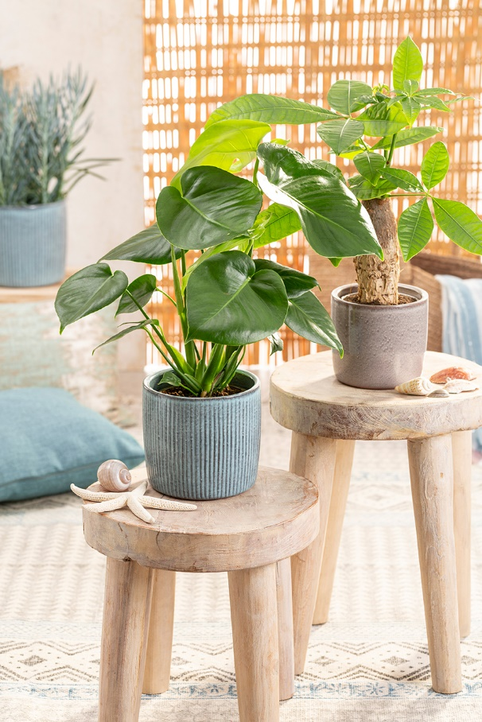
Inspired by vacations! Scheurich now evokes memories of the most beautiful weeks of the year with a series of cover pots that makes you long for the ocean. Seaside uses a maritime look to bring a beach feel to the home year-round. Perfectly suited for dreaming and relaxing!

Like handmade souvenirs on a trip, Lagoon and Seashell present an authentic and original design. The grooved surfaces of these ceramic pots resemble soft waves and come in an attractive turquoise shade and that of a wind struck sandy beach. The smooth surfaced version catches the light with its turquoise coloured depth and mother-of-pearl effect. When light shines on Seaside, the pots are transformed with wonderful reflections which help to reinforce a feel-good mood. The thick-walled shape of Seaside works like a visual anchor in the room.

If you want to extend your vacation, combine Seaside with fitting accessories; turquoise coloured textiles, natural materials or light wood furniture are great additions for a relaxing feel. Scheurich’s favourite plant companions are the money tree (Pachira aquatica), the popular Monstera or the succulent Curio ficoides ‘Blues’. Beautifully coordinated interiors can be created with several Seaside pots in different locations providing oases of relaxation in the room.

Seaside is 100% waterproof and Made in Germany.

Available sizes:
13, 15, 18 and 21 cm

About Scheurich

My pot. My style.
Scheurich knows how to meet different customer demands and to offer fashionable products for current trends in interior styles. With designs at the pulse of the time, proven quality Made in Germany and one of the largest offerings of shapes in the market, the family business is the No. 1 in Europe when it comes to plant containers for the in- and the outdoors. The sustainable ceramics and plastics production lines at the German locations make Scheurich a pioneer of environmental protection. The company is part of the Scheurich-Group and will be carbon neutral in its plants by 2035.

