Recalibrate Life

Zen by Scheurich

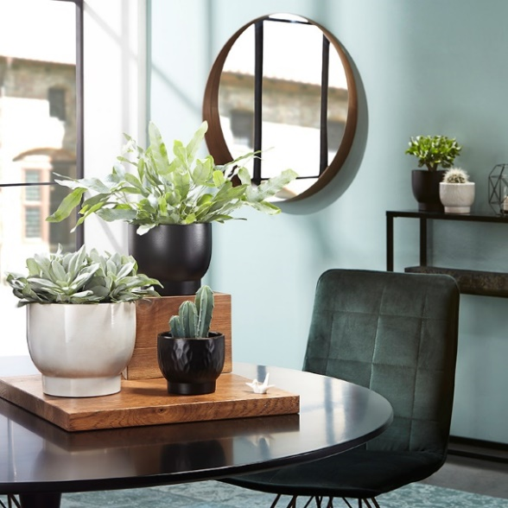
A mindful lifestyle is becoming more and more appealing - little rituals, minimalism or consciously living the moment are prevalent and bring calmness and structure to a hectic routine. Scheurich is now visually picking up on this way of living. The new cover-pot series Zen symbolically represents the simple elegance, so evident in Japanese art and culture, showing that mindfulness can be integrated easily.

Like Yin and Yang these cover pots present themselves in the colours of Ebano and Opale and celebrate the sensual counterparts, this continues in the contrast of the different surfaces and the shiny and matt effects. While the smooth surface picks up the clear line of the Far East design trend, the crafted looking finish physically embodies the connectedness of Zen with nature.

The base of the Zen series leans on the design of Japanese tea bowls and reminds us to take a break to relax and recharge every now and then. The Ebano cover pots pay homage to the Japanese method of Raku which was used mostly for dishes used in tea ceremonies, and gives the surface a certain vividness. Opale features a very fine and soft finish with a speckled glaze effect. All pots are 100% watertight and are ideal partners for succulents, cacti or fern. Vesuvius (Senecio cephalophorus), golden polypody (Phlebodium aureus), blueberry cactus (Myrtillocactus) or the curly jade plant (Crassula ovate Undulata) underline the Zen concept.

Self care - making the living space a place of relaxation - is something that many people long for and in Zen, the many small elements and steps of its design help enable the reaching of this goal. Scheurich anchors this concept with the peace of mind afforded by its quality label Made in Germany.

Available sizes:
11, 13, 15 and 18 cm

About Scheurich

My pot. My style.
Scheurich knows how to meet different customer demands and to offer fashionable products for current trends in interior styles. With designs at the pulse of the time, proven quality Made in Germany and one of the largest offerings of shapes in the market, the family business is the No. 1 in Europe when it comes to plant containers for the in- and the outdoors. The sustainable ceramics and plastics production lines at the German locations make Scheurich a pioneer of environmental protection. The company is part of the Scheurich-Group and will be carbon neutral in its plants by 2035.

