1 pot = 1 tree

Tree-planting campaign by Scheurich

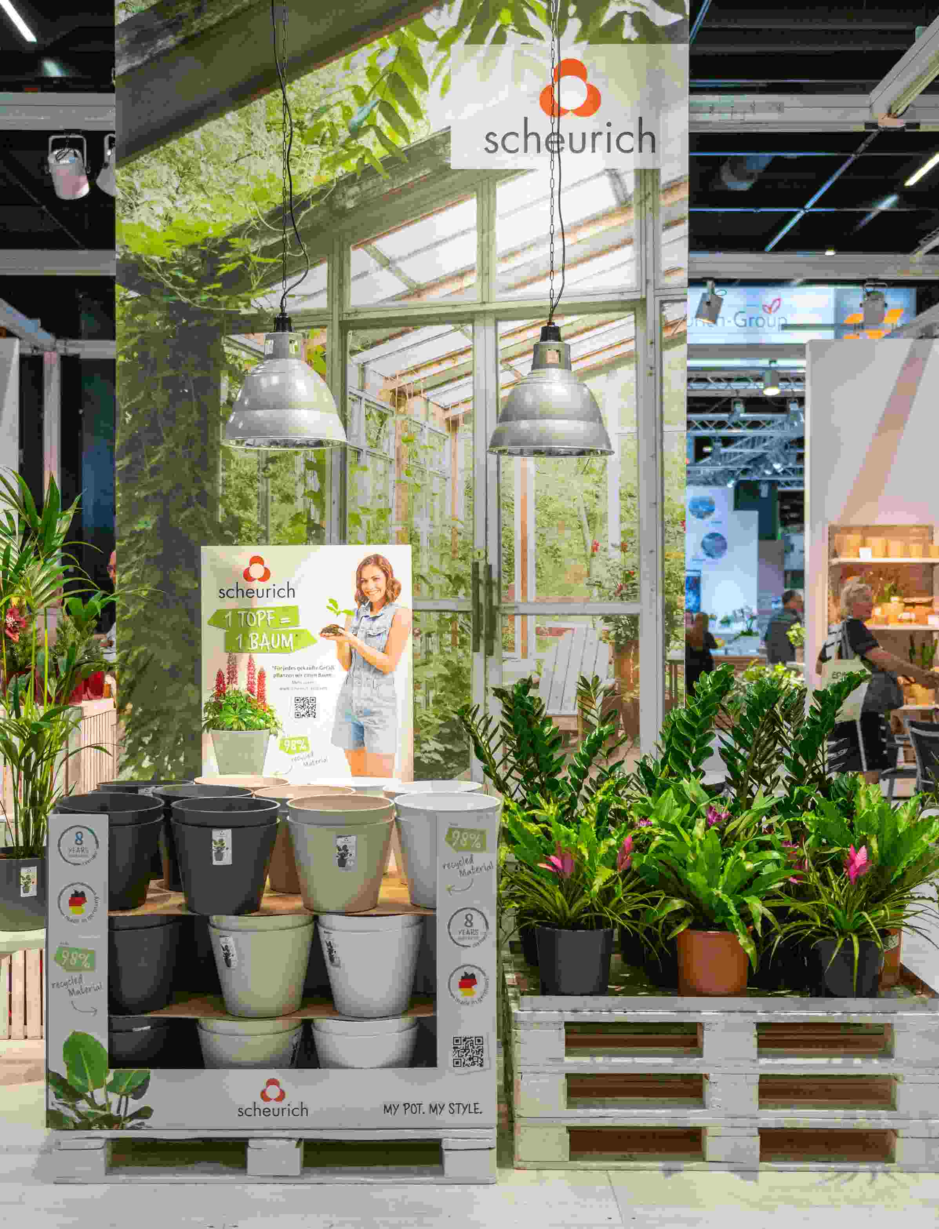
An attention-grabbing POS campaign with an important message: Scheurich gets active against climate change with the “1 pot = 1 tree” campaign. For every plant container sold in the Groove, Groove+, Purista and Purista+ series, Scheurich will plant a tree in cooperation with Eden Reforestation.

And customers can watch the growth of the scheme. On the “Sustainability” page at www.scheurich.de a “tree count” shows the number of plants already planted as part of this campaign. The non-profit partner Eden Reforestation has taken up the mission to rebuild landscapes destroyed by deforestation in developing countries. Trees and forests are after all essential for climate protection.

By buying Groove, Groove+, Purista and Purista+ in sizes 30 and 40cm, plant fans can now take direct action against climate change - far beyond this tree-planting campaign. Both ranges are manufactured by Scheurich as indoor and outdoor versions using the sustainably sourced plastic Certuro, which contains up to 98% recycled material. Certuro itself is 100% recyclable and has an 8 year guarantee.

The label “Made in Germany” additionally stands for quality, short shipment routes, flexibility and secure jobs - all of which is part of Scheurich’s focus on sustainability in both thought and action - for a liveable future for next generations. With this tree planting campaign Scheurich again demonstrates far-sightedness and responsibility as a global company in this time of climate change.

If you want to make a mark, you have to be visible! At the POS this tree planting campaign with an eye-catching pallet surround and header board presents and motivates with simple call-to-action elements. A QR code is incorporated in the design and leads directly to further information at www.scheurich.de/baum.

About Scheurich

My pot. My style.
Scheurich knows how to meet different customer demands and to offer fashionable products for current trends in interior styles. With designs at the pulse of the time, proven quality Made in Germany and one of the largest offerings of shapes in the market, the family business is the No. 1 in Europe when it comes to plant containers for the in- and the outdoors. The sustainable ceramics and plastics production lines at the German locations make Scheurich a pioneer of environmental protection. The company is part of the Scheurich-Group and will be carbon neutral in its plants by 2035.

