Great colours, great effects

Blue Batik by Scheurich

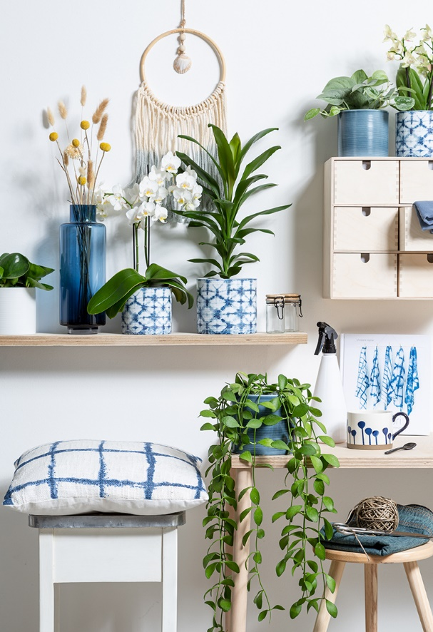
Origami, Matcha tea and the art of forest bathing - Japanese influences bring joy into our daily routines. And now it’s the return of Shibori: the traditional fabric dyeing technique from Japan that creates bright patterns and is all the rage again; and for Scheurich’s new cover pots Blue Batik it is a real aesthetic upgrade.

Batik at its best! The Shibori look in blue and white on a cylindrical cover pot with clear geometric shapes refines the classic Batik style. It’s exactly the right design for an on-trend plant container in a modern interior that features a natural touch. To complete this style, the ambience can be complemented with further accessories in the Shibori pattern. Souvenirs of a trip to Asia or plants like Phalaenopsis (butterfly orchids) are perfect matches.

Scheurich reinforces the resemblance of textile with the fascinating ridged surface structure of Blue Batik and with the cover pot Blue Jeans, which features the washed and colour-faded look typical of jeans. Just as in fashion, Batik and Jeans are also coordinated partners in interior design and combine to create a thought through look, conveying clarity and liveliness when combined with bright, solid coloured cover pots. Blue Jeans looks especially appealing with a spotted ivy (Scindapsus pictus “Silvery Ann”) or a Dischidia nummularia.

Scheurich presents once more its sense for great product design: Cosmopolitan on the outside, “Made in Germany” and 100% watertight on the inside.

Available sizes:
Cover pots 828 Blue Batik:
12, 14, 16 and 19 cm
Cover pots 828 Blue Jeans:
12, 14, 16, 19, 23 and 28 cm

About Scheurich

My pot. My style.
Scheurich knows how to meet different customer demands and to offer fashionable products for current trends in interior styling. With its fingers on the pulse of design, proven quality ‘Made in Germany’ and one of the largest offerings of shapes in the market, the family business is No. 1 in Europe when it comes to plant containers for both the indoors and out. The sustainable ceramics and plastics production lines at both German locations make Scheurich a pioneer of environmental protection. The company is part of the Scheurich Group and will be carbon neutral in its plants by 2035.

