Capturing the jungle

Wildlife by Scheurich

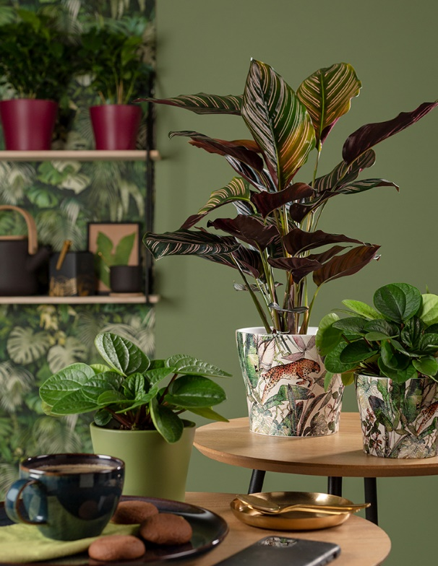
The fascinating jungle - a magical place brimming with animals and plants. With its new cover-pot series Wildlife, Scheurich brings us the essence of the primordial rain forest, far removed from a world of the internet and films. The design resembles prints from old books, telling stories of other worlds that nonetheless complement the modern urban jungle.

Extravagant and still discrete! The bold design with its exotic plants and leaping jaguar catches the eye right away. Aesthetically, the surface softens the jungle pattern and emphasises a natural look. Fans of interior design will enhance the atmosphere with additions such as tropical plants; for example Calathea (prayer plant) or Peperomia (Dwarf pepper) combined with coordinating cover pots in Burgundy and Oliva that capture the colours of blossoms and leaves of the jungle, hence creating a beautiful tropical picture.

Charming look - modern technique: Scheurich uses an innovative technique to produce this modern design. Wildlife is an attractive inhabitant of window sills, side tables or sideboards, especially in homes where the décor is extravagant and bold with patterned wallpapers and golden accessories.

In combining several Wildlife cover pots a special kind of Urban Jungle can grow indoors. This extraordinary item from the current Scheurich product range is 100% watertight and is Made in Germany.

Available sizes:
Cover pot Wildlife: 11, 13 and 15 cm
Cover pot Burgundy: 11, 13, 15, 17, 19 and 21 cm
Cover pot Oliva: 11, 13, 15, 17, 19 and 21 cm

About Scheurich

My pot. My style.
Scheurich knows how to meet different customer demands and to offer fashionable products for current trends in interior styling. With its fingers on the pulse of design, proven quality ‘Made in Germany’ and one of the largest offerings of shapes in the market, the family business is No. 1 in Europe when it comes to plant containers for both the indoors and out. The sustainable ceramics and plastics production lines at both German locations make Scheurich a pioneer of environmental protection.

.

