For catnip

Catview by Scheurich

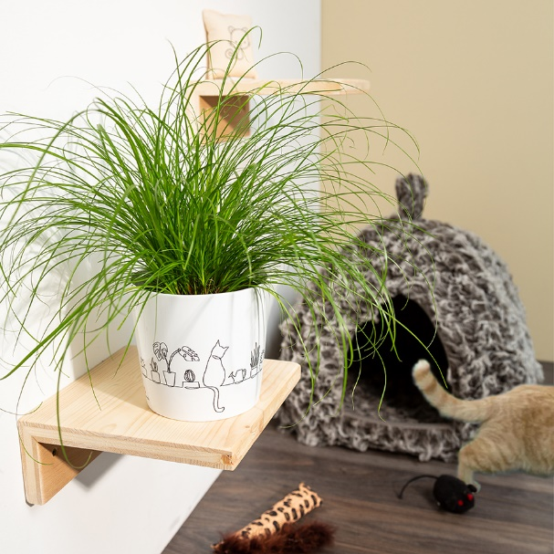
If you like cats, you’ll love the new cover pot by Scheurich. Catview features a trendy one line art design and leaves no doubt; it’s all about the domestic tiger. With cat grass (Cyperus) inside, Catview becomes the new hangout spot for velvet paws and an eye-catching feature for their humans.

The luscious green of the plant is a refreshing contrast to the black and white of the pot. What looks nice, also has an important function. Cat grass is a sensible feeding supplement especially for house cats and should be available year around - no problem with Catview. Place it on the windowsill, close to the cat tree or a cat ladder to make it easily accessible.

A real-life scene: the Catview design shows a house cat sitting on the windowsill. The new cover pot will warm cat lovers’ hearts - no matter if bought or presented as a gift.

Catview is Made in Germany and 100% watertight.

Available sizes:
13 cm

About Scheurich

My pot. My style.
Scheurich knows how to meet different customer demands and to offer fashionable products for current trends in interior styling. With its fingers on the pulse of design, proven quality ‘Made in Germany’ and one of the largest offerings of shapes in the market, the family business is No. 1 in Europe when it comes to plant containers for both the indoors and out. The sustainable ceramics and plastics production lines at both German locations make Scheurich a pioneer of environmental protection.

