For blossoming jewels

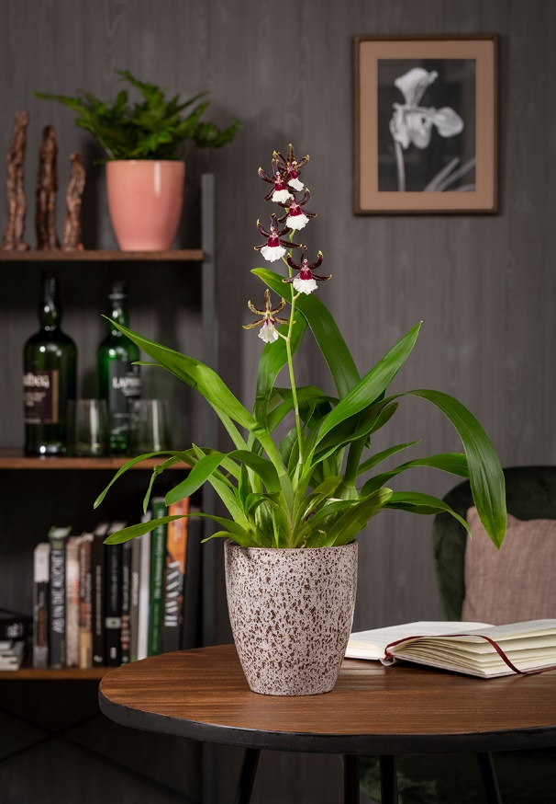
Solido Orchid containers by Scheurich

With their air of master craftsmanship,high quality orchids like the multi-coloured Odontonia Samurai are love at first sight. Their perfection in the finest of detail is unveiled only on closer inspection. Scheurich presents sophisticated plant containers for these floral wonders of nature with its series Solido.

Simple craftsmanship and yet elegant: Solido wins over fans of orchids with three shiny to satin-matt glossy designs. Roccia features a unique finish with a natural look. Rosea shimmers on all sides and suits ferns perfectly. The design Perla, which resembles natural stone, complements the series.

Solido combines different surface finishes for a coordinated bigger picture. Be it individually or in combination with other Scheurich cover pots, orchid arrangements create impressive highlights in the home. The strong designs with their typical ceramic character create a natural contrast to the soft structure of the orchids and their velvety blossoms.

All plant containers are Made in Germany and 100% watertight.
Available Sizes:
Orchid containers: 15 cm
Cover pots: 13, 15, 18, 21, 24 and 28 cm

About Scheurich

My pot. My style.
Scheurich knows how to meet different customer demands and to offer fashionable products for current trends in interior styling. With its fingers on the pulse of design, proven quality ‘Made in Germany’ and one of the largest offerings of shapes in the market, the family business is No. 1 in Europe when it comes to plant containers for both the indoors and out. The sustainable ceramics and plastics production lines at both German locations make Scheurich a pioneer of environmental protection.

