Watering at its best

Nelly by Scheurich
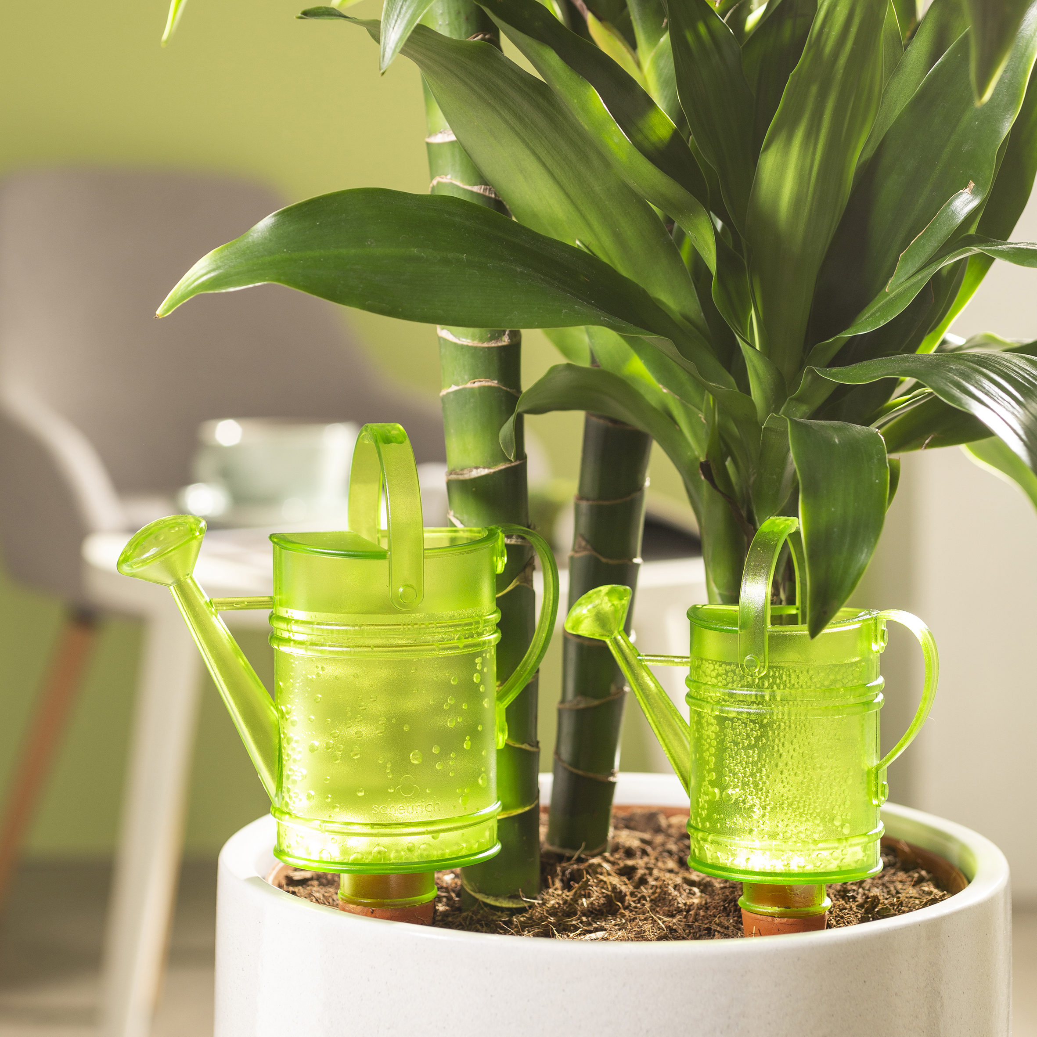
Bördy has cult-like status! This cheerful bird took plant lovers’ hearts by storm, and with it, Scheurich launched its range of smart watering assistants for indoors and out. It’s still a success story today, which Scheurich has continued to tell, with creative water reservoirs like the champagne glass Copa.

Now Scheurich adds a new model to the field; Nelly. Watering cans embody the task of watering, whether they are large or small. Nelly waters all by itself and is eye-catching in every plant pot. The charming design resembles the classic British metal watering cans. Additional to the fact that “watering less often” is an advantage, this little watering can, made of translucent plastic, also scores with its loving details and attractive colours in Green, Red and Grey.

For any gardeners who go away at short notice, or who are preoccupied and don’t always remember to water everyday, this accessory is a tiny big helper both indoors and outdoors. Favourite plants are reliably supplied with this essential liquid for up to 4 days. The water reservoir holds up to 110 ml and can be refilled easily through the opening on top. Depending on the dryness of the soil, Nelly dispenses water through its clay cone to green plants, potted herbs and blossoming beauties.

By the way, stylish watering assistants are a nice gift idea for all who love plants and a relaxed daily routine.

Available size;
110 ml
240 ml

About Scheurich

My pot. My style.
Scheurich knows how to meet different customer demands and to offer fashionable products for current trends in interior styling. With its fingers on the pulse of design, proven quality ‘Made in Germany’ and one of the largest offerings of shapes in the market, the family business is No. 1 in Europe when it comes to plant containers for both the indoors and out. The sustainable ceramics and plastics production lines at both German locations make Scheurich a pioneer in environmental protection.

