True Italian style & Made in Germany

Toscana by Scheurich

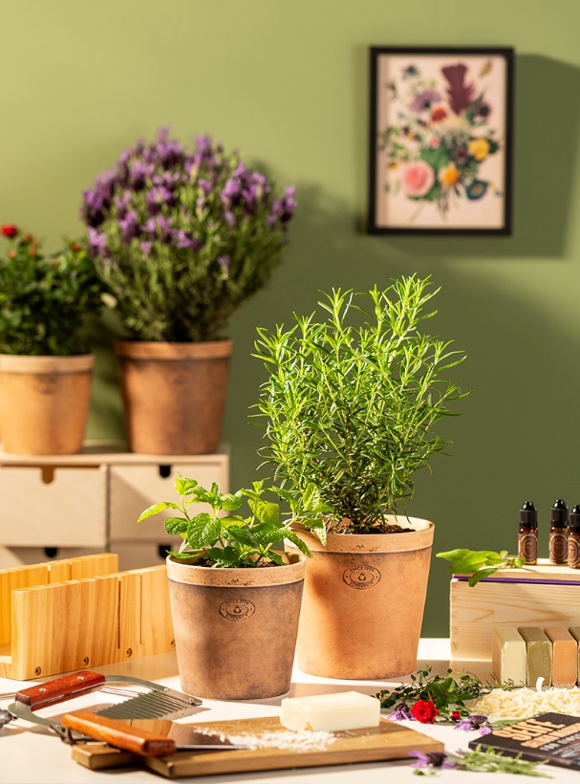
Mediterranean life: If you love Mediterranean living, you can't do without Toscana. The new cover pot series from Scheurich captures the classic colour scheme of longed-for Italian destinations and emulates the matt texture of natural materials. The Toscana Nero and Luminoso versions create a warm living ambience, which Scheurich is now imprinting with its authentic mark.

Inspired by the Mediterranean, created from the heart; Nero combines a terracotta look with charming traces of a previous life, perhaps left behind by the seasons. Perfect for putting a mint in the spotlight, for example - best placed within easy reach in the kitchen or on the patio for sparkling summer drinks. Luminoso beckons with a rich rosemary, it is a few shades lighter and tonally perfectly matched to Nero. A potted rose or lavender also look really good in Toscana and reflect the magic of Italy.

Both in craftsmanship and stylistically, this look is absolutely in vogue and so homemade lavender soaps can meet cover pots like Toscana in the knowledge that everything has been designed down to the last detail. The visually highlighted rim refines the planters and evokes the association "as if made by hand" - without compromising on proven Scheurich quality. The Italian terracotta look is 100 percent waterproof so can be used safely indoors without saucers. Benvenuto a casa!

Available sizes:
Cover pots: 12, 14, 16 and 19 cm

About Scheurich

My pot. My style.
Scheurich knows how to meet different customer demands and to offer fashionable products for current trends in interior styling. With its fingers on the pulse of design, proven quality ‘Made in Germany’ and one of the largest offerings of shapes in the market, the family business is No. 1 in Europe when it comes to plant containers for both the indoors and out. The sustainable ceramics and plastics production lines at both German locations make Scheurich a pioneer of environmental protection. The company is part of the Scheurich Group and will be carbon neutral in its plants by 2035.

