New colours Khaki and Carbon

Groove from Scheurich

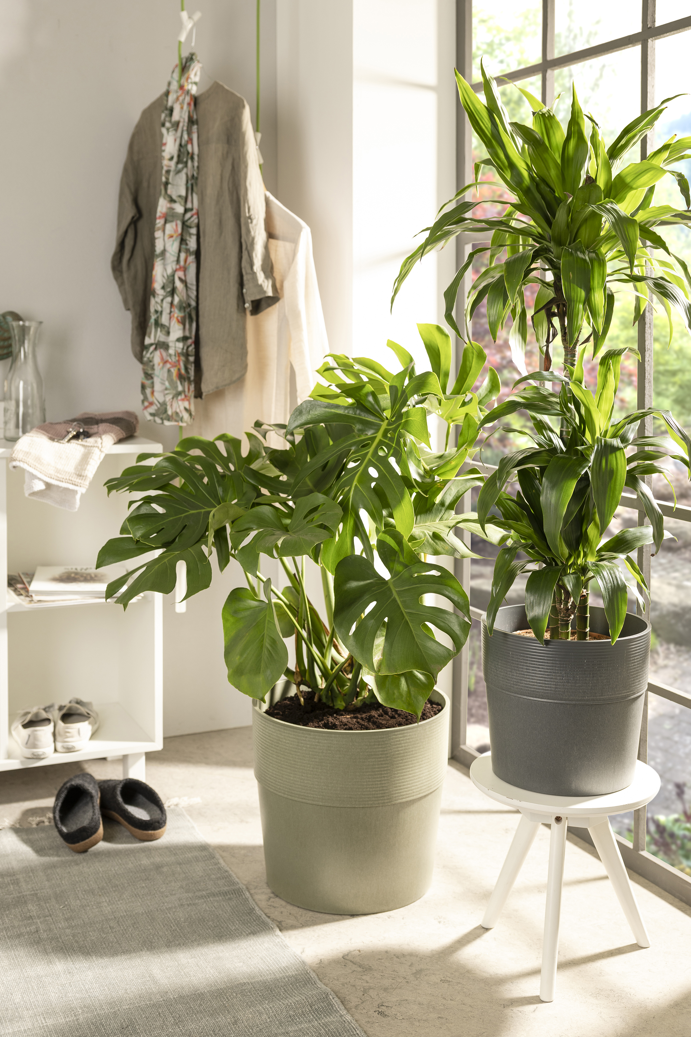
There is always something to discover in the Urban Jungle: with the natural pairings of monstera (window leaf), dracaena (dragon tree) and other plants, the popular Groove planter range is now also available in Khaki and Carbon. The two new colours appeal with their natural tones and matt finish. Groove combines informality with on-trend design without stealing the show from the real Green Living stars – the plants.

The star remains - especially in the field of XXL houseplants - the lush green, the expansive leaves, in all their facets, and the special features of the individual plants. But it is only with bold designs like Groove that living with plants becomes a conscious lifestyle choice. With its grooved surface relief and thick-walled design, Groove is a true signature piece that bears the unmistakable mark of Scheurich and yet is unique.

Feel the Groove! Once you have decided on the high quality planters from Scheurich, you will be happy to let the Urban Jungle grow beyond window sills, side tables and chests of drawers. Groove is versatile in different sizes and colours and comes with a clear conscience as it is made in Germany from the innovative plastic Certuro, comprising up to 98 percent recycled material. Scheurich provides an 8 year guarantee on the planters.

Available sizes:
14, 17, 21, 25, 30 and 40 cm

About Scheurich

My pot. My style.
Scheurich knows how to meet different customer demands and to offer fashionable products for current trends in interior styling. With its fingers on the pulse of design, proven quality ‘Made in Germany’ and one of the largest offerings of shapes in the market, the family business is No. 1 in Europe when it comes to plant containers for both the indoors and out. The sustainable ceramics and plastics production lines at both German locations make Scheurich a pioneer of environmental protection. The company is part of the Scheurich Group and will be carbon neutral in its plants by 2035.

