Art Déco: Elegance in perfect form

Peacock by Scheurich

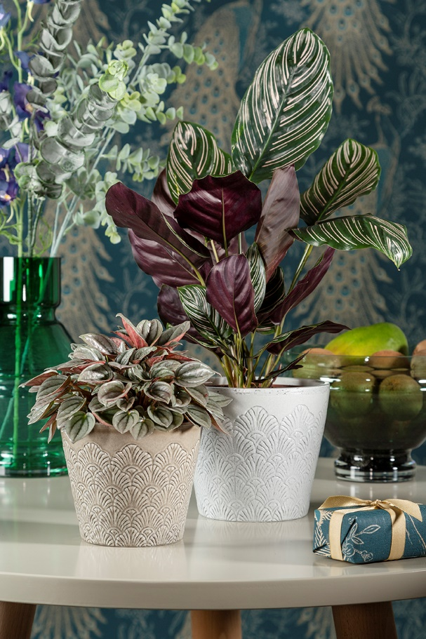
It’s time to step up, because the Mid Century Style is back with a real design classic. The 50’s and 60’s with all its character is reborn with the Peacock cover pot series. Organic shapes meets natural colours and opulent exuberance. Scheurich brings this attitude to life with Peacock and the classical Art Déco element of the peacock feather in absolute style. The result is a sensual design with true individuality and 3D effects.

Peacock is brought to life in Vintage White, Vintage Greige and Vintage Violet. The recesses of the décor, the iridescent colour gradients and the uneven rim emphasise its handmade look. Each planter is slightly different, 100 percent waterproof and Made in Germany.

Peacock with its classical design and character remains the visual linchpin in the living ambience, befitting of this featured style. Friends of this retro trend also gravitate towards other peacock themed accessories such as wallpaper. Peacock can also be combined with coloured glass vases and dried flowers - whatever you like… no limits!

Home is the most important place, no matter what time. Relaxation, well-being and variety are paramount for you in your home. This is reflected in Peacock: everything is a little softer and warmer without taking away any of the striking elements. Together with elegant plants such as a Peperomia Caperata (Dwarf Pepper) or Calathea Ornata (Basket Maranthe), Peacock celebrates the return of Mid Century Style.

Available sizes:
Cover pots: 13, 15, 18 and 21 cm

About Scheurich

My pot. My style.
Scheurich knows how to meet different customer demands and to offer fashionable products for current trends in interior styling. With its fingers on the pulse of design, proven quality ‘Made in Germany’ and one of the largest offerings of shapes in the market, the family business is No. 1 in Europe when it comes to plant containers for both the indoors and out. The sustainable ceramics and plastics production lines at both German locations make Scheurich a pioneer of environmental protection. The company is part of the Scheurich Group and will be carbon neutral in its plants by 2035.

