Naturally luxurious

Leaves from Scheurich

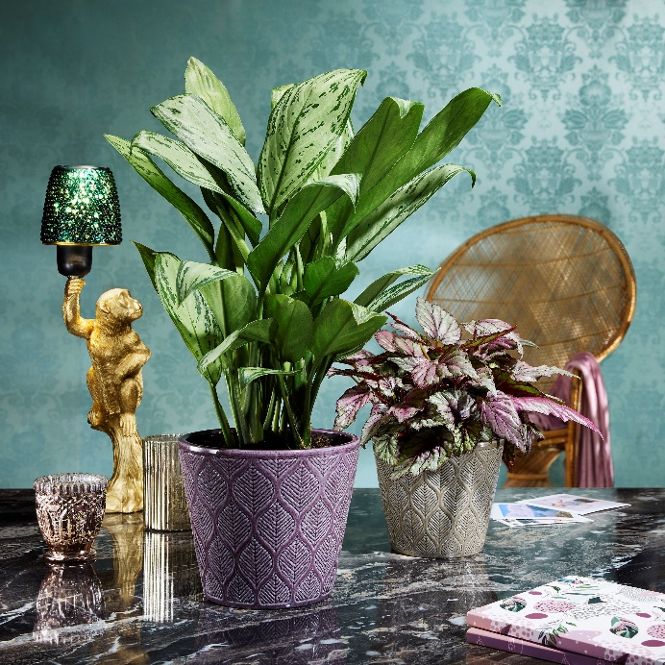
Floral, decorative and in fashionable colours - that's how Art Deco works today! Scheurich combines style-defining elements with a modern look in the new Leaves cover pot series. Foliage in perfectly shaped symmetry adorn Leaves in the Vintage White, Vintage Greige and Vintage Violet colourways and create a décor with an eye-catching effect.

Leaves loves the extravagant - anyone who reaches for this new planter can now experiment a little: For example, in terms of plants; with a leaf begonia or a Chinese evergreen (Aglaonema), or use in conjunction with marble, perhaps place alongside fun, gold-coloured or glass accessories? The planter is always the centre of attention with its relief surface and colourfulness.

Art Deco and elegant Mid-Century design return to the living room at regular intervals. Everyday objects can easily be transformed into signature pieces and leave their mark on an interior design. The only question that remains is the choice of colour; Vintage White brings in Art Deco Light, while Vintage Greige emphasises the relief of Leaves even more. The opulent style becomes very apparent with Vintage Violet - the rich purple puts Leaves in a particularly striking light. The three colours can also be combined in many different ways to your heart’s content.

Leaves has a charming, eye-catching finish with a characteristic rim at the top and bottom, which gives the cover pot a fitting shape to show it off to its best advantage. With Leaves, Scheurich has once again been inspired by the richness of the past, reinterpreted it and realised it using a high-quality stamping process. Leaves is Made in Germany and absolutely waterproof.

Available sizes:
Cover pots: 13, 15, 18 and 21 cm

About Scheurich

My pot. My style.
Scheurich knows how to meet different customer demands and to offer fashionable products for current trends in interior styling. With its fingers on the pulse of design, proven quality ‘Made in Germany’ and one of the largest offerings of shapes in the market, the family business is No. 1 in Europe when it comes to plant containers for both the indoors and out. The sustainable ceramics and plastics production lines at both German locations make Scheurich a pioneer of environmental protection. The company is part of the Scheurich Group and will be carbon neutral in its plants by 2035.

