Level up!

Plant stand from Scheurich

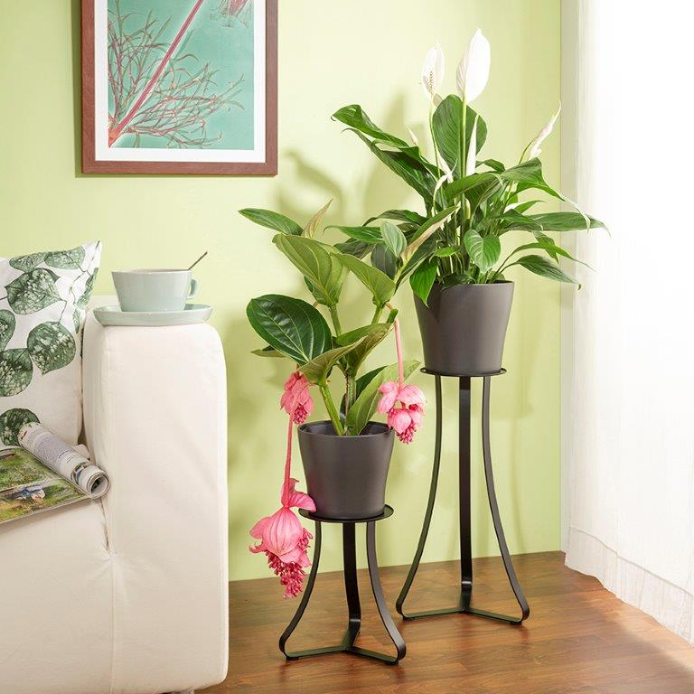
Trend-conscious plant fans can now raise their green favourites to a whole new level. Pedestals are back in fashion in modern living environments and Scheurich is realising this trend with its decorative plant stands. Select a plant, place it on the plant stand and use its new height to expressively showcase the plant at its best: a Medinilla, for example, with its typically drooping flowers, now has enough space to unfold and is shown to its best advantage.

Two designs, two heights, two colours: The Avignon pedestal impresses with its straight lines and harmoniously continues the shape of the planters – sometimes matching tonally, sometimes contrasting in colour. The Paris plant stand has a dynamic look. The curved legs elegantly echo the lines of many plant containers. But the combination of the plant and its decorative stand also makes an eye-catching highlight in the room and can be combined in many ways.

To co-ordinate with different furnishing styles, the plant stands are available in white matt or satin black and in two heights - and can also be arranged in pairs or as a trio.

The new plant stands are made of high quality metal and complement designer pieces, enriching the stylish ambience in a home. They create a constant base that can be creatively used by changing planters and plants at will, such as monocots, Vriesea or Dieffenbachia.

Available sizes:
Plant stand Avignon: 27 and 51 cm
Plant stand Paris: 27 and 51 cm

About Scheurich

My pot. My style.
Scheurich knows how to meet different customer demands and to offer fashionable products for current trends in interior styling. With its fingers on the pulse of design, proven quality ‘Made in Germany’ and one of the largest offerings of shapes in the market, the family business is No. 1 in Europe when it comes to plant containers for both the indoors and out. The sustainable ceramics and plastics production lines at both German locations make Scheurich a pioneer of environmental protection. The company is part of the Scheurich Group and will be carbon neutral in its plants by 2035.

