One style - 10 colours

Lilly watering can and sprayer from Scheurich

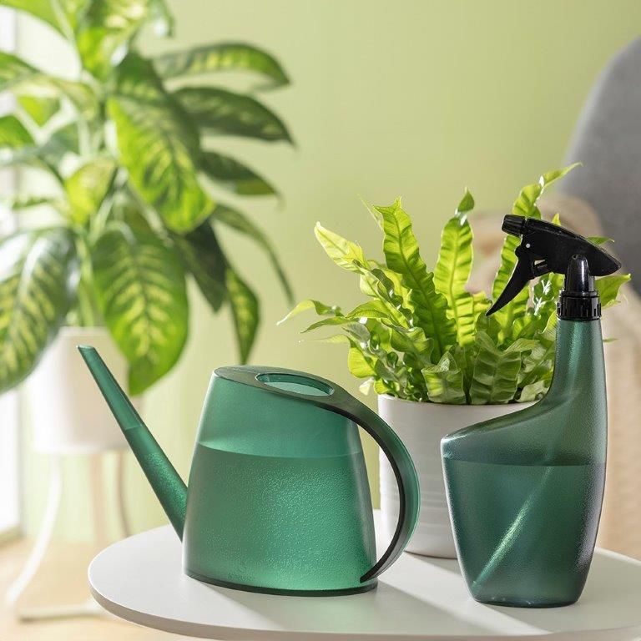
In a wealth of colours and always at the ready: that's the watering can Lilly from Scheurich – available in a matt or translucent finish and in a wide range of shades. With its great design, Lilly takes centre stage in any urban jungle. And when Lilly isn't providing plants with water, it radiates great style alongside the matching spray bottle.

A dream team for plant care: the design and colours of the watering can and sprayer are perfectly coordinated. Reach for Lilly and you can immediately see the water level through the translucent plastic making it easy to judge when you need a refill. The 1.5 litre watering can is also designed to prevent water from spilling; Lilly's slim spout makes it easy to water accurately and the ergonomic handle is comfortable to hold.

With the sprayer, plant lovers have Smart Watering optimally under control – just hold it, press gently and supply the flowers and leaves with a well-dosed spray mist. The metal spray head of the 0.7 litre spray bottle is particularly durable.

From a choice of Matt Anthracite, Taupe and Green to Clear Viridian and Lime: the colourful watering cans and sprayers are made of recyclable plastic and are easy to fill.

Available sizes:
Watering can Lilly: 1,5 litre
Sprayer: 0,7 litre

About Scheurich

My pot. My style.
Scheurich knows how to meet different customer demands and to offer fashionable products for current trends in interior styling. With its fingers on the pulse of design, proven quality ‘Made in Germany’ and one of the largest offerings of shapes in the market, the family business is No. 1 in Europe when it comes to plant containers for both the indoors and out. The sustainable ceramics and plastics production lines at both German locations make Scheurich a pioneer of environmental protection. The company is part of the Scheurich Group and will be carbon neutral in its plants by 2035.

