Decoration trend: Wicker baskets

Natural Collection from Scheurich

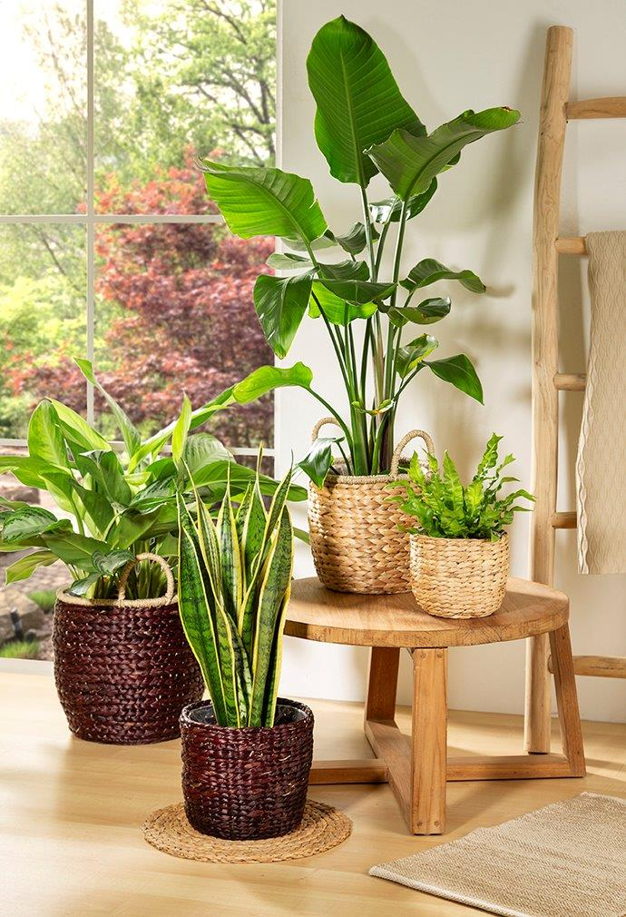
Handmade by Nature. Handmade for you. If you want to give your urban jungle a particularly natural look, Scheurich now has just the basket. The new Natural Collection presents wicker basket ware made of seagrass and water hyacinth in wonderfully diverse ways. The beautiful wicker containers come with and without handles, as hanging baskets, coarsely woven or more delicately woven and in one or two colours.

Whether creating a boho look, a green interior or a Scandinavian furnishing style, natural materials have long been an integral part of a natural home ambience and, thanks to Scheurich, are now claiming even more space as their own in the shape of these planters. With its many attractive designs, the Natural Collection symbolises naturalness. The wicker planters are made by hand from the quickly renewable and naturally occurring raw materials of seagrass and water hyacinth and therefore also score points in terms of their ecological credentials - both plants thrive without fertilisers and additional watering.

Within the Natural Collection, there is a range of water hyacinth containers with a coarse and fine mesh finish in the colours Nature and Brown - with and without handles. These baskets look particularly pleasing when decorated with a bird of paradise flower (Strelitzia nicolai), cob thread (Aglaonema) or bird’s nest fern (Asplenium 'Crispy Wave'), for example.

The Natural Collection also consists of various seagrass baskets with and without handles in the colours Nature, Brown, Nut, Green, White and Black or any combination of these. How about a basket with a lucky feather (Zamioculcas zamiifolia) or bowstring hemp (Sansevieria)? And a hanging basket with a dwarf pepper (Peperomia eden)? The ceramic pots from Scheurich also fit beautifully into the overall concept.

When nature has a hand in it, every basket is unique. The usual Scheurich quality naturally remains as standard: all baskets are made watertight with sturdy foil or a solid plastic insert. Scheurich also attaches great importance to fair working conditions and environmentally friendly processing practices during production.

Available sizes:
Essential Line water hyacinth:
Nature, Brown: 16, 20, 24, 26, 30 and 34 cm
Essential Line water hyacinth:
Nature, Brown: 18, 20, 23, 25 and 28 cm
Essential Line seagrass:
Nut, Brown, Green: 13, 15, 17, 19, 22, 24 and 26 cm
Essential Line seagrass:
White, Black: 15, 17, 22, 24 and 32 cm
Perfect Line seagrass:
Nut, Brown: 23, 27, 33 and 37 cm

About Scheurich

My pot. My style.
Scheurich knows how to meet different customer demands and to offer fashionable products for current trends in interior styling. With its fingers on the pulse of design, proven quality ‘Made in Germany’ and one of the largest offerings of shapes in the market, the family business is No. 1 in Europe when it comes to plant containers for both the indoors and out. The sustainable ceramics and plastics production lines at both German locations make Scheurich a pioneer of environmental protection. The company is part of the Scheurich Group and will be carbon neutral in its plants by 2035.

