Plant care - made easy

Planter with watering insert from Scheurich

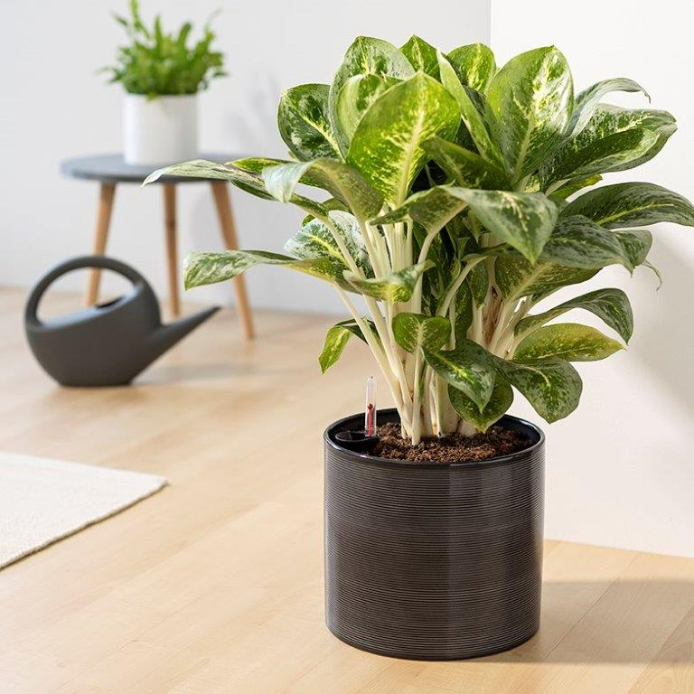
Water less. Enjoy more. Scheurich is currently presenting the first ceramic planter with an integrated watering insert. Scheurich thus fulfils the desire for a beautifully designed home without having to invest a lot of time and knowledge in plant care.

Once planted, the cover pot provides your favourite green plants with a constant and reliable supply of water, preventing waterlogging and drying out. The watering insert is customised to the planter and consists of an insert and a watering indicator. The water is stored in the reservoir under the plant and released to the roots as required. A quick glance at the watering indicator is all it takes to determine whether it is time to water. This means that Aglaonema or Asplenium Crispy Wave will thrive even if you don't have "green fingers".

With its striking grooved look and classic colour scheme in glass grey and panna, the cover pot fits perfectly into a modern living environment. Straightforward in design, the ceramic planter is a timeless accessory with practical added value. Cover pots in trendy colours and decors can be combined again and again to change the all-over look in the room.

Available size:
23 cm

About Scheurich

My pot. My style.
Scheurich knows how to meet different customer demands and to offer fashionable products for current trends in interior styling. With its fingers on the pulse of design, proven quality ‘Made in Germany’ and one of the largest offerings of shapes in the market, the family business is No. 1 in Europe when it comes to plant containers for both the indoors and out. The sustainable ceramics and plastics production lines at both German locations make Scheurich a pioneer of environmental protection. The company is part of the Scheurich Group and will be carbon neutral in its plants by 2035.

