Colour Matching
Cottage from Scheurich

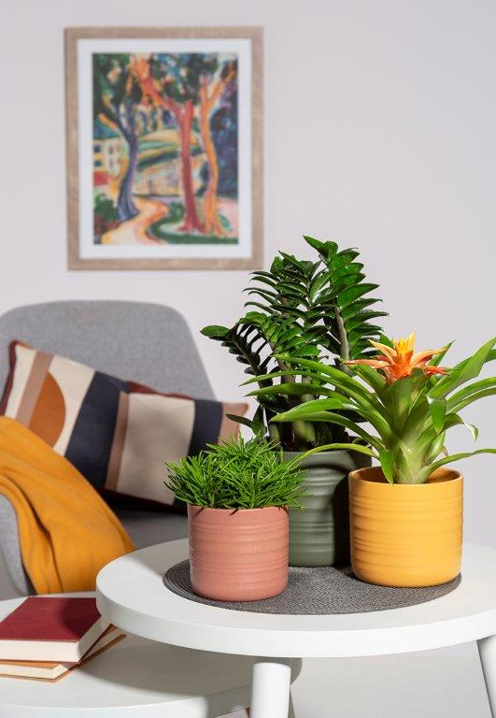
Colours make life beautiful. They create good feelings and evoke positive associations. Scheurich uses this effect with the new colours Curcuma, Sunburn and Forest Green and presents cover pots in trendy colours to immerse the modern living environment in a feel-good atmosphere.

Curcuma warms you up: the colour reminds of turmeric, a delicious spice that energises and exudes sensuality. Sunburn is the answer to the question of which shade of red is currently in and sets expressive accents. And Forest Green brings freshness to any area and emphasises the effect of plants.

Arranged as a trio, Curcuma, Sunburn and Green Forest create a good mood. Deep yellow, bright red and lush green present themselves as a lively mix. In combination with a ragwort (Senecio 'Himalaya'), a Guzmania 'Flava' and a lucky feather (Zamioculcas), a great combination is created that immediately catches the eye. The stylish planters also complement furnishing styles in shades of grey and white particularly well.

The simple design allows the fascinating grooved look to take centre stage - the matt colours further emphasise the handcrafted character of the planters. If the trio is too colourful for you, opt for a high-contrast duo or choose a favourite colour and let it speak for itself.

All planters are Made in Germany and 100 % waterproof.

Available sizes:
Cover pots: 12, 14, 17, 20 und 23 cm

About Scheurich

My pot. My style.
Scheurich knows how to meet different customer demands and to offer fashionable products for current trends in interior styles. With designs at the pulse of the time, proven quality Made in Germany and one of the largest offerings of shapes in the market, the family business is the No. 1 in Europe when it comes to plant containers for the in- and the outdoors. The sustainable ceramics and plastics production lines at the German locations make Scheurich a pioneer of environmental protection. The company is part of the Scheurich-Group and will be carbon neutral in its plants by 2035.

