Smart Outdoor-Design

Plano+ from Scheurich

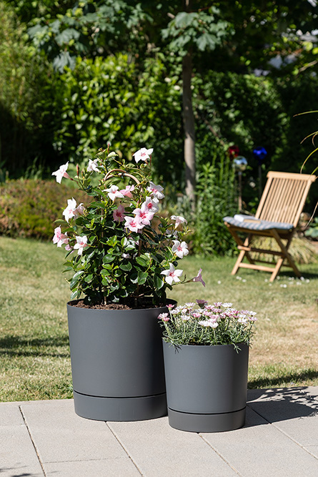
Plano+ makes it click: With the new range, Scheurich combines the saucer and planter into a single unit. This is not only for practical reasons, but is also part of Scheurich's new design campaign for the outdoor area. With Plano+, this can be seen in the modern, clear design, the matt surface in the colours Moss Green, Pure Grey, Siena Red and Metallic Grey and the deliberately designed distance between the planter and saucer.

Welcome to contemporary outdoor living: terraces, gardens and balconies have become part of the living area and are often designed with the same dedication and a personalised plan. Sustainability is playing an increasingly important role for plant fans. And Plano+ is also convincing in this respect: The new planter is made from Reduro, a Scheurich in-house development made from recycled material and is 100% recyclable.
What would a trendy planter look be without healthy plants? Water drainage holes in the base of Plano+ prevent waterlogging. Thanks to the design-integrated saucer, the plants do not dry out and less watering is required even in hot weather.

The lightness and compact combination of planter and saucer make it easy to find the right location for Mandevilla (Dipladenia), Daisybush (Osteospermum) , Bacopa flower (Sutera cordata) and other plants, depending on the season.

Plant lovers are also well equipped with Plano, the outdoor planter without the saucer. For indoor use, Scheurich presents the Plano range in smaller sizes and a different colour concept.
All planters are Made in Germany and come with a 5-year guarantee.

Available sizes:
29, 39 and 47 cm

About Scheurich

My pot. My style.
Scheurich knows how to meet different customer demands and to offer fashionable products for current trends in interior styling. With its fingers on the pulse of design, proven quality ‘Made in Germany’ and one of the largest offerings of shapes in the market, the family business is No. 1 in Europe when it comes to plant containers for both the indoors and out. The sustainable ceramics and plastics production lines at both German locations make Scheurich a pioneer of environmental protection. The company is part of the Scheurich Group and will be carbon neutral in its plants by 2035.

