Get the Look

Lino+ von Scheurich

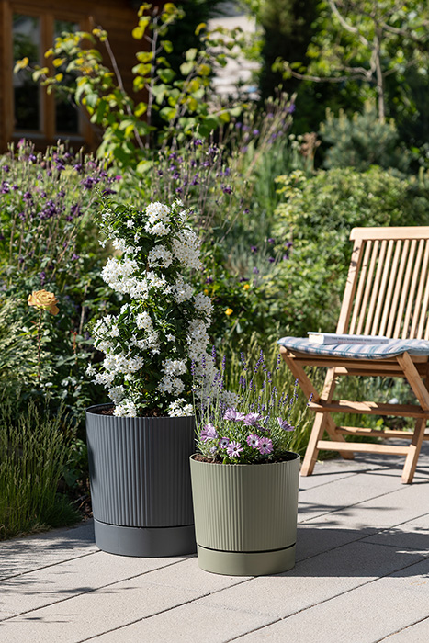
Today, the same demands are placed on outdoor planters as on indoor planters. The new Lino+ range from Scheurich meets these requirements by combining form and function in an attractive design. A smart click system turns the planter and saucer into an unmistakable unit, which is available in Moss Green, Pure Grey, Siena Red and Metallic Grey.

The stylish design of Lino+ with its vertical grooves, linear look and the deliberate use of a step between the pot and saucer creates a high-quality effect and beautifully complements popular lounge furniture on the patio and in the garden. And the whole thing is made from Reduro, a plastic developed by Scheurich from recycled material that conserves resources and is sustainable. Lino+ is also completely recyclable.

Lino+ in four strong matt colours and various sizes looks just as good on stone slabs as it does on wooden terraces and can be harmoniously planted with tall plants such as a jasmine nightshade (Solanum laxum) or a duo of lavender and a Daisybush “polar star”. Moss Green, Pure Grey, Siena Red and Metallic Grey are stylishly understated and allow the plants to take centre stage. Drainage holes in the base prevent waterlogging and ensure that the plants continue to enjoy themselves - also because the remaining water in the saucer prevents them from drying out. This means less watering for plant lovers and more protection for the plants themselves on warm summer days.
Lino+ also impresses with its durability and low weight for maximum flexibility when the seasons change - the stable combination of planter and saucer makes it easy to transport.

Lino is the same product as the outdoor planter without the design-integrated saucer. For indoor use, Scheurich presents the Lino range in smaller sizes and a different colour concept.

All planters are Made in Germany and come with a 5-year guarantee.

Available sizes:
29, 39 and 47 cm

About Scheurich

My pot. My style.
Scheurich knows how to meet different customer demands and to offer fashionable products for current trends in interior styling. With its fingers on the pulse of design, proven quality ‘Made in Germany’ and one of the largest offerings of shapes in the market, the family business is No. 1 in Europe when it comes to plant containers for both the indoors and out. The sustainable ceramics and plastics production lines at both German locations make Scheurich a pioneer of environmental protection. The company is part of the Scheurich Group and will be carbon neutral in its plants by 2035.

