Growth for the popular outdoor range

Linetto from Scheurich

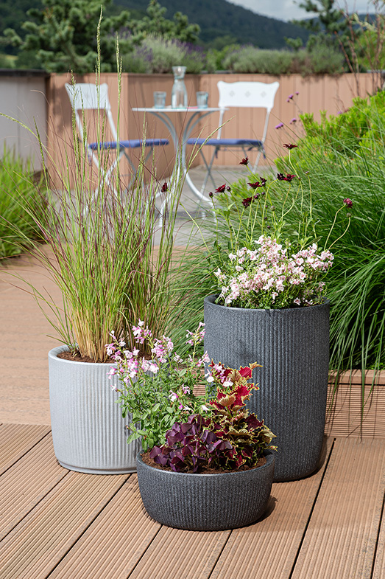
As soon as the days get longer, the desire to get the patio, garden or balcony in shape and start the outdoor season increases every year. With the Linetto planters made of the recyclable plastic Garduro, the outdoor living atmosphere always blossoms all along the line. Scheurich is now adding two bowls, an oval planter and another size for the tall planter to the successful series.

Unmistakably Linetto: the new additions feature vertical grooves, the lively three-dimensional surface and the usual thick-walled texture in Stony Black and Stony Grey and the modern, natural character. Plant fans are delighted to see more plants and therefore new containers for the outdoor area: a love grass (Eragrostis curvula) looks beautiful in a planter. The bowl and the new ‘smaller’ tall planter with a chocolate flower and an elfin spurge (Diascia hybrids) are filled with several plants such as red clover (Oxalis triangularis), coloured nettle (Solenostemon scutellarioides) and autumn sage (Salvia greggii).

All Linetto products have a closable water drain for healthy plant growth: when the drain is open, there is no waterlogging. And when the days get shorter again, the drain is closed tightly and sensitive plants find a place to hibernate inside without leaving marks on sensitive floors. Linetto is also an eye-catcher in the living area.

With the high-quality recyclable plastic Garduro, Scheurich is also making a strong statement against wasting resources. Made with a high proportion of recycled material, the plastic has a 10-year guarantee, is UV and frost-resistant and is Made in Germany.

Available sizes:
Planters: 30, 40 and 47 cm
High planters: 40 and 54 cm
Bowls: 30 and 40 cm
Oval bowls: 46 cm

About Scheurich

My pot. My style.
Scheurich knows how to meet different customer demands and to offer fashionable products for current trends in interior styling. With its fingers on the pulse of design, proven quality ‘Made in Germany’ and one of the largest offerings of shapes in the market, the family business is No. 1 in Europe when it comes to plant containers for both the indoors and out. The sustainable ceramics and plastics production lines at both German locations make Scheurich a pioneer of environmental protection. The company is part of the Scheurich Group and will be carbon neutral in its plants by 2035.

