Give the gift of pleasure & time

Break from Scheurich

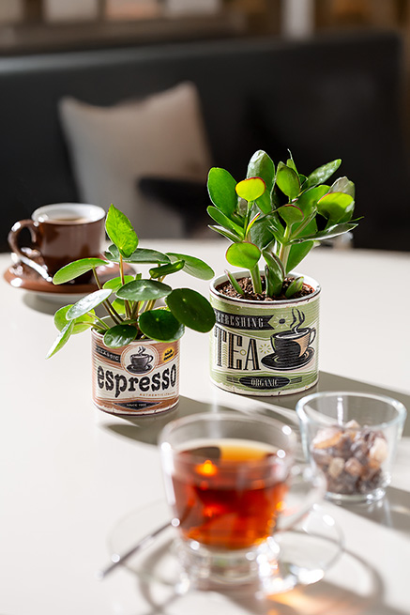
Tea and coffee are popular gifts. Gift-givers always like to complement these two classic indulgences with other suitable gifts such as rock sugar, espresso cups or, more recently, the new Break mini cover-pot range from Scheurich. Espresso Time and Tea Time, together with a lucky thaler (Pilea peperomioides) or a thick leaf (Crassula), charmingly summarise the gift message: Treat yourself to a break regularly! Which means as much as: Take care of yourself.

Scheurich is known for its stylish gifts and their emotional message, which are well received by the recipient. The decorative mini cachepots look like vintage packaging for coffee powder and tea and develop their authentic look thanks to the ribbed surface. This vibrancy enhances the character of the supposed ‘tins’ and reflects the light beautifully. In the living room or home office, Espresso Time and Tea Time always catch the eye and remind us of what is important: take a break regularly and consciously enjoy the time.

Of course, the mini cover-pots are also 100 per cent waterproof and made in Germany.

Available sizes:
7 and 9 cm

About Scheurich

My pot. My style.
Scheurich knows how to meet different customer demands and to offer fashionable products for current trends in interior styling. With its fingers on the pulse of design, proven quality ‘Made in Germany’ and one of the largest offerings of shapes in the market, the family business is No. 1 in Europe when it comes to plant containers for both the indoors and out. The sustainable ceramics and plastics production lines at both German locations make Scheurich a pioneer of environmental protection. The company is part of the Scheurich Group and will be carbon neutral in its plants by 2035.

