A breath of fresh air for home oases of well-being

Breeze from Scheurich

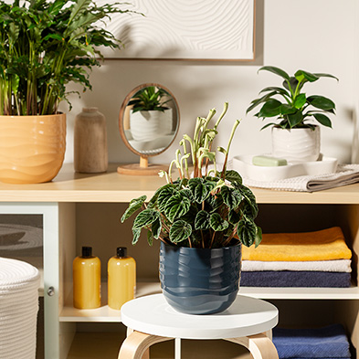
The new Breeze planter range from Scheurich brings movement into the living environment and creates a desire for change - for example in the bathroom. The wave-shaped relief décor of Breeze in the colours Deep Ocean, Yellow Beach, Rush Grass and Bone White literally freshens up existing furnishings and decorations with its contrasting colours and dynamic look.

Scheurich presents a trio of blue, yellow and white Breeze as an eye-catcher between wellness must-haves. Deliberately used accessories and colours to suit your personal taste leave stress and everyday worries at the door. Wall decorations with a 3D surface complement the bold charm of Breeze and visually support the desired flow of energy in the room.

Plants such as philodendron, dwarf pepper (Peperomia caperata Lilian) or a Calathea rufibarba Bluegrass naturally round off the small makeover in the spa at home. And when sunlight is reflected in the glossy finish of Breeze, the world simply stays outside during me-time. If you want to relax, you have to be able to trust: Breeze is Made in Germany and absolutely waterproof - making the ceramic planters ideal for wooden bathroom furniture too. Natural materials harmonise perfectly with the handcrafted look of Breeze.

With Breeze and Scheurich, quality once again enters your home in a pleasantly valuable way.

Available sizes:
13, 15, 18, 21 and 24 cm

About Scheurich

My pot. My style.
Scheurich knows how to meet different customer demands and to offer fashionable products for current trends in interior styling. With its fingers on the pulse of design, proven quality ‘Made in Germany’ and one of the largest offerings of shapes in the market, the family business is No. 1 in Europe when it comes to plant containers for both the indoors and out. The sustainable ceramics and plastics production lines at both German locations make Scheurich a pioneer of environmental protection. The company is part of the Scheurich Group and will be carbon neutral in its plants by 2035.

