Show your colours in style

Plano by Scheurich

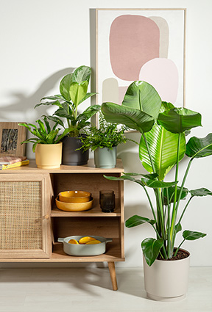
A great combination! Scheurich's new Plano plant pot series offers plant lovers a wide range of design options. The four trendy colours are coordinated and invite creative arrangements. Plano is also made from Reduro, a plastic developed by Scheurich, whose high recycled content is a clear commitment to sustainable design.

Matt Yellow, Matt Sage and Avorio combine to create a harmonious, natural atmosphere that is ideal for modern, cosy living rooms as well as for creating a spa feeling in the bathroom. Replacing Matt Yellow with Nero creates a casual Scandinavian look. As a colour quartet of Avorio, Matt Sage, Matt Yellow and Nero, Plano also fits perfectly into a living environment with wooden furniture and light-coloured floors. There are no limits to the design possibilities with Plano – not least because of the many different sizes in which the plant pot is available.

Thanks to its matt surface, Plano takes a back seat visually, leaving the stage to plants such as sword fern (Nephrolepis), nest fern (Asplenium), silver bay (Aglaonema silver bay) or bird of paradise (Strelitzia).

Even though the focus is on the attractive appearance, Scheurich impresses as usual in terms of material: Reduro is recyclable, resource-saving, robust, made in Germany and comes with a 5-year guarantee.

If you're thinking bigger, you'll find planters up to 47 cm for outdoor use: Plano and Plano+ with integrated saucers in Moss Green, Pure Grey, Siena Red and Metallic Grey perfectly complement the indoor series of the same design.

Available sizes:
13, 15, 18, 21, 25 and 29 cm

About Scheurich

My pot. My style.
Scheurich knows how to meet different customer demands and to offer fashionable products for current trends in interior styling. With its fingers on the pulse of design, proven quality ‘Made in Germany’ and one of the largest offerings of shapes in the market, the family business is No. 1 in Europe when it comes to plant containers for both the indoors and out. The sustainable ceramics and plastics production lines at both German locations make Scheurich a pioneer of environmental protection. The company is part of the Scheurich Group and will be carbon neutral in its plants by 2035.

