Perfectly shaped and glossy

Avora Glaze by Scheurich

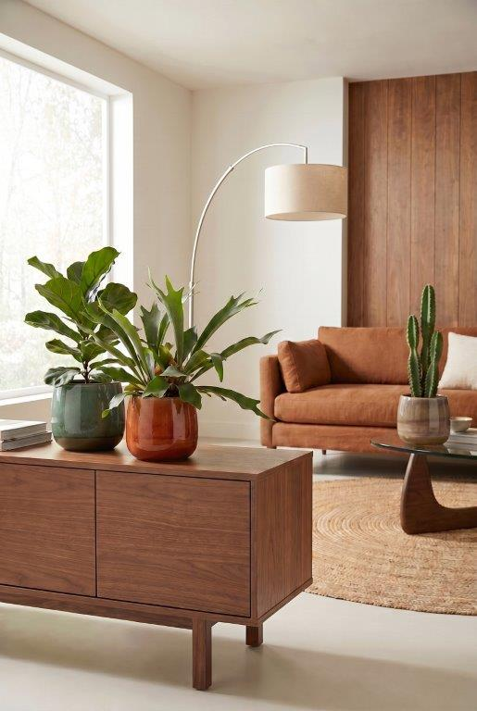
When high-quality furniture and cover pots are in perfect harmony, Avora Glaze by Scheurich is right up there. Available in the colours Ambra, Smeralda, Olivina, Naturale and Bruna, Avora Glaze reflects interior styles from various design trends – such as Italian flair, the Nordic look or vintage style.

The drop shape of Avora Glaze blends beautifully into the lifestyle of plant lovers: with its handcrafted appearance and glazed finish, the range has a high-quality ceramic feel. This effect makes Avora Glaze an eye-catcher wherever it is placed. The contrasting rim, the organic shape and the striking surface immediately catch the eye – creating a sense of vitality based on natural, earthy tones.

Plants such as the fiddle-leaf fig (Ficus lyrata), staghorn fern (Platycerium bifurcatum) or western spurge (Euphorbia acuriensis) are a perfect match and harmoniously complete the overall look – wherever Avora Glaze is, it creates a cosy atmosphere. The cover pot looks great alongside wooden furniture and coarse textiles made from wool, linen or cotton.

Ambra, Smeralda, Olivina, Naturale and Bruna can be combined to create a stylish look, both with each other and with existing accessories. The warm brown tone of Ambra, accented with the green and blue of Olivina and Smeralda, is a hit with trend-conscious plant enthusiasts. As is Scheurich’s quality standard: Avora Glaze is Made in Germany and completely waterproof. The sophisticated design combines technical expertise with high aesthetic appeal.

Available sizes:
Cover pots Avora Glaze: 16, 19, 22 and 24 cm

About Scheurich

Designed for Your Life.

The premium supplier of planters and innovative plant-related solutions is unveiling a new look and brand positioning – whilst maintaining the same high standards of quality. Over its nearly 100-year history, Scheurich has played a key role in shaping design trends. Today, Scheurich stands for far more than just ceramics: aesthetic products that bring a sense of well-being into everyday life. It is the people who define the brand – a family with a name and a history. Scheurich takes responsibility for today and for future generations.

