Top Trend: Opulence

Blooms by Scheurich

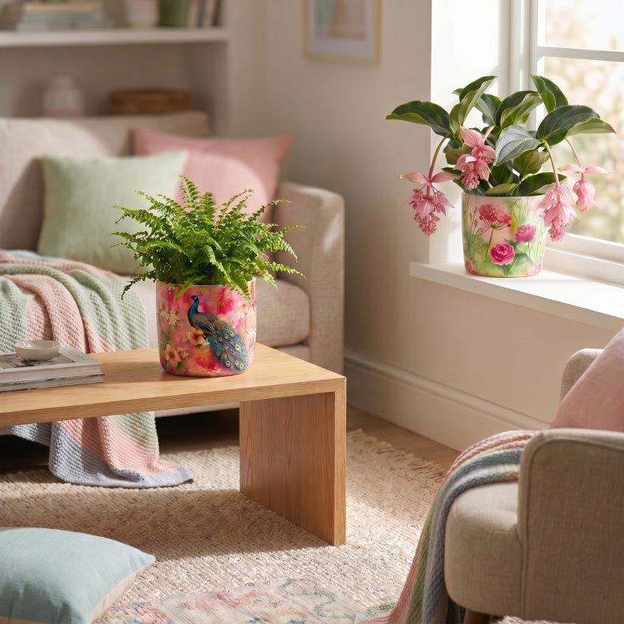
A new kind of opulence is back! Scheurich has created the Blooms range for plant lovers who currently enjoy surrounding themselves with colourful and eye-catching accessories. Four cover pot ranges featuring botanical motifs that stir the imagination and bring interior design dreams to life.

Summer Bloom, Tropical Bloom, Peacock Bloom and Garden Bloom conjure up magnificent images in the mind, which Scheurich brings to life on the thick-walled planters thanks to the high-quality Polyprint process. Here you’ll find peacocks, cockatoos and many tropical plants to discover – hibiscus blossoms, Monstera leaves and our feathered friends, for example, are rendered in exquisite detail.

Blooms represents an explosion of colour in a modern living space, which plant lovers can confidently decorate with these eye-catching pieces. Just like in a real jungle, the eye catches something new every time. When the cover pot becomes a canvas, the Blooms designs appear to be captured in a watercolour style – this soft-focus style blends attractively into opulently furnished rooms.

Blooms showcases tropical plants such as Medinilla and Phalaenopsis particularly well. It then appears as though their leaves continue the floral motifs beyond the planter – this enhances the urban jungle effect and makes your home literally blossom.

Blooms is Made in Germany and 100 per cent waterproof.

Available sizes:
Cover pots Summer Bloom, Tropical Bloom,
Peacock Bloom, Garden Bloom: 13, 15 and 18 cm

About Scheurich

Designed for Your Life.

The premium supplier of planters and innovative plant-related solutions is unveiling a new look and brand positioning – whilst maintaining the same high standards of quality. Over its nearly 100-year history, Scheurich has played a key role in shaping design trends. Today, Scheurich stands for far more than just ceramics: aesthetic products that bring a sense of well-being into everyday life. It is the people who define the brand – a family with a name and a history. Scheurich takes responsibility for today and for future generations.

