Focus on plants

Calma by Scheurich

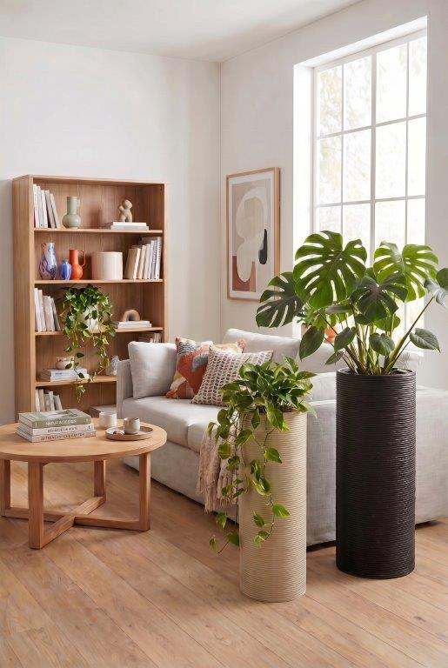
Plants remain popular home accessories. In modern living spaces, where the windowsill is no longer a place for decoration, Calma by Scheurich offers an attractive solution for showcasing philodendrons, pothos or monsteras. The stylish pedestal becomes an eye-catcher and enhances the living environment with its elegant presence.

Inside too, Calma impresses with the high-quality finishing characteristic of Scheurich. The indoor plant column features a sturdy insert in which the plant pots stand securely. Combined with a plant, Calma creates a very harmonious look – available with a pedestal in either sand-coloured or black plastic. Calma can also be easily combined in terms of colour and the two available sizes to give rooms a uniform style.

Calma, made from high-quality Garduro plastic, fits perfectly into any green living space. Thanks to its light weight, Calma can be easily moved to create trendy living spaces or to provide new plants with the ideal growing conditions.

Calma is Made in Germany.

Available sizes:
Calma: 60 and 65 cm

About Scheurich

Designed for Your Life.

The premium supplier of planters and innovative plant-related solutions is unveiling a new look and brand positioning – whilst maintaining the same high standards of quality. Over its nearly 100-year history, Scheurich has played a key role in shaping design trends. Today, Scheurich stands for far more than just ceramics: aesthetic products that bring a sense of well-being into everyday life. It is the people who define the brand – a family with a name and a history. Scheurich takes responsibility for today and for future generations.

