Plant care with charm

Freddy by Scheurich

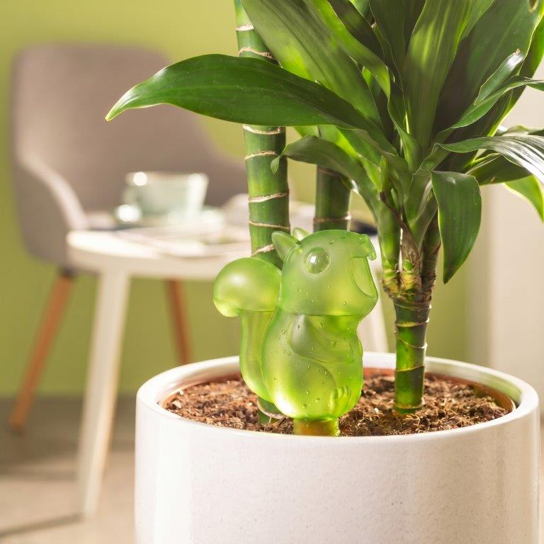
Just as squirrels hoard nuts in the wild, the original watering device Freddy stores water to ensure houseplants are constantly supplied with this vital liquid. As the latest water reservoir in the Scheurich range, Freddy bridges short breaks, helps with the stresses of everyday life or makes up for a lack of green fingers – thanks to the tried-and-tested Scheurich system with a clay cone.

Place Freddy in the soil, fill with fresh water and let the clever squirrel get to work. This practical accessory is available in translucent Green, Grey and Smoke Brown, as well as in two sizes for up to four days of regular water release. The translucent design ensures plant lovers always have a clear view of the water level.

Anyone who loves the well-known watering aid Bördy will also be happy to place Freddy in a cover pot or two – both impress with Scheurich quality and wonderfully charming animal details. Freddy’s little rodent teeth are just as sure to bring a smile as his characteristic fluffy tail and little snout – the latter reliably reminds you to top up the water for your favourite plants in your home.

Freddy is also a great gift idea for all plant enthusiasts among your friends and family – whether as a watering newbie in the urban jungle or as a companion to Bördy.

Available sizes:
Freddy: 130 and 230 ml

About Scheurich

Designed for Your Life.

The premium supplier of planters and innovative plant-related solutions is unveiling a new look and brand positioning – whilst maintaining the same high standards of quality. Over its nearly 100-year history, Scheurich has played a key role in shaping design trends. Today, Scheurich stands for far more than just ceramics: aesthetic products that bring a sense of well-being into everyday life. It is the people who define the brand – a family with a name and a history. Scheurich takes responsibility for today and for future generations.

