Lovely. Attractive. Organic.

Lao by Scheurich

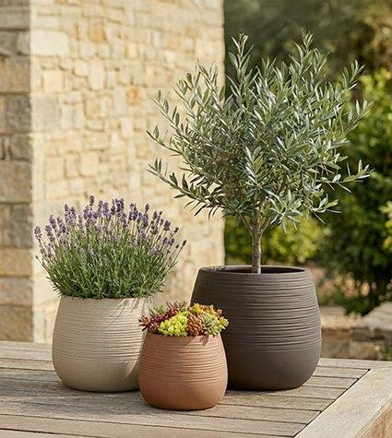
Plant lovers are currently creating a modern look for their patios or gardens with a handmade aesthetic: for example, with Scheurich’s new Lao outdoor range, featuring organic shapes and a colour palette that reflects that classic Mediterranean patio vibe. Drop-shaped planters and bowls are the perfect choice for comfortable outdoor living.

The surface texture, which appears scratched, is reminiscent of handcrafted ceramics—and only when you touch the planter does it become clear: Lao, made from the high-quality plastic Garduro, is a true lightweight. In this way, Mediterranean flair combines with Scheurich’s expertise.

It becomes particularly authentic when Lao is planted with an olive tree, a lavender bush, or succulents. Anyone thinking of vacations in Greece, Italy, or Spain quickly envisions earthy colours. Lao brings this image to life in your home’s outdoor space with Sand, Maple, and Umber. Sand pairs beautifully with wooden furniture or existing planters in various colors. Complemented by Maple and Umber, Lao creates a harmoniously coordinated atmosphere on the patio.

Lao is also practical, featuring the typical Scheurich drainage hole with a plug: this hole prevents waterlogging after heavy rainfall. When used outdoors, the plug is safely stored in the ‘parking position’ at the bottom of the planter. When moving the planter indoors for the winter, it is quickly to hand and seals the opening completely drip-free. This makes Lao a true all-rounder, made in Germany.

Available sizes:
Planter Lao: 30, 40 and 47 cm
Planter Lao Long: 54 cm

About Scheurich

Designed for Your Life.

The premium supplier of planters and innovative plant-related solutions is unveiling a new look and brand positioning – whilst maintaining the same high standards of quality. Over its nearly 100-year history, Scheurich has played a key role in shaping design trends. Today, Scheurich stands for far more than just ceramics: aesthetic products that bring a sense of well-being into everyday life. It is the people who define the brand – a family with a name and a history. Scheurich takes responsibility for today and for future generations.

