Trending: A stylish stone look

Mondo by Scheurich

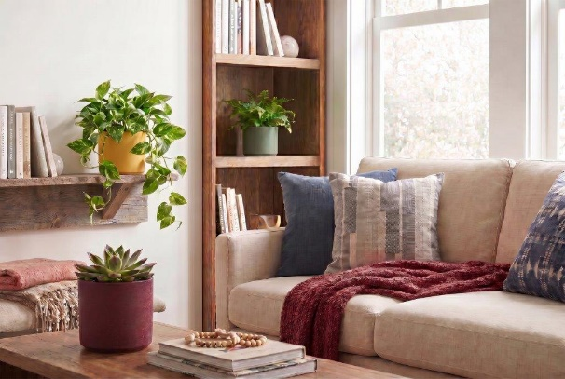
It is often the small details that determine quality. Scheurich demonstrates just how this works with the Mondo cover pot: the distinctive stone surface is a pleasure to the touch and, available in a wide range of colours, adds artisanal accents to modern living spaces. The glossy finish on the inside of the pot provides a striking contrast to the textured exterior. This finish is high-quality, easy to care for and a real hit with plant lovers.

Mondo also offers a wide range of colours: from Burgundy Stone and Yellow Stone to Whisper Stone, Basalt Stone and Moss Stone, there’s something for everyone. In beige, grey and green, the cylindrical cover pot is even available in an XL size. Arrange, combine, decorate – the world of Mondo knows almost no bounds when it comes to stylishly furnishing your home.

This allows the cover pot range to be used to create individual designs for living rooms, bedrooms, kitchens and bathrooms. Mondo in Burgundy, Moss and Yellow Stone, paired with favourite plants such as Echeveria, Pothos or indoor ferns, brings a touch of Mediterranean cosiness to the living room. It looks particularly harmonious when furniture and textiles, like Mondo itself, catch the eye with a distinctive surface texture.

With a trio comprising Whisper, Basalt and Moss Stone, the Scandi style brings a cosy feel to the bathroom or bedroom. And in the kitchen, it’s all about a colourful mix – here, Mondo can be arranged in various sizes and all colours to suit your mood.

Mondo’s high-quality appearance is enhanced by the small, elegant rim, which tapers the straight bowl shape towards the base and lends it a more delicate charm. Mondo is made in Germany and 100 per cent waterproof.

Available sizes:
Cover pots Whisper Stone, Basalt Stone, Moss Stone:
12, 14, 16, 19, 21, 24, 27 and 32 cm
Cover pots Burgundy Stone, Yellow Stone:
12, 14, 16, 19 and 21 cm

About Scheurich

Designed for Your Life.

The premium supplier of planters and innovative plant-related solutions is unveiling a new look and brand positioning – whilst maintaining the same high standards of quality. Over its nearly 100-year history, Scheurich has played a key role in shaping design trends. Today, Scheurich stands for far more than just ceramics: aesthetic products that bring a sense of well-being into everyday life. It is the people who define the brand – a family with a name and a history. Scheurich takes responsibility for today and for future generations.

