Striking accents for modern living

Origami and Retro Bubbles by Scheurich

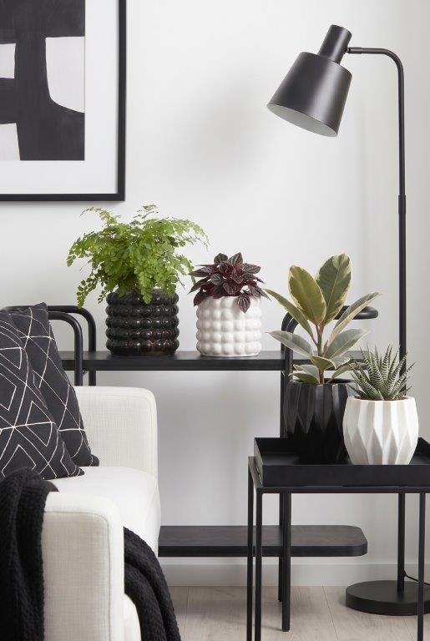
The cover pots themselves are just as striking as their names: Origami and Retro Bubbles by Scheurich feature corners, edges and curves, and above all, they are real eye-catchers. With their own distinctive styles, both cover pots in black and white immediately catch the eye of plant and design enthusiasts.

Origami reimagines the traditional Japanese art of paper folding as a plant pot to showcase plants in a striking way. This effect is enhanced with a Adiantum capillus-veneris, a peperomia (Peperomia caperata), a rubber tree (Ficus elastica) or a zebra cactus (Haworthia). In white, Origami emphasises the classic paper-like character, which here is crafted from thick-walled ceramic. The black version highlights Origami’s design even more.

The Retro Bubbles attract just as much attention. Equally striking and three-dimensional, this range of cover pots gives rooms an organic, playful feel – Scheurich achieves a harmonious balance through the geometric arrangement of the Bubbles. Combined with other accessories or a trendy armchair, these cover pots bring a sense of dynamism to any home.

As is customary with Black & White, the two colours are combined in a striking way – and this also applies to the plant pots. With Origami and Retro Bubbles, this liveliness – so popular with many plant enthusiasts – finds its way into the urban jungle, thanks to the beautiful texture.

Available sizes:
Cover pots Origami: 12, 15 and 18 cm
Cover pots Retro Bubbles: 12, 15 and 18 cm

About Scheurich

Designed for Your Life.

The premium supplier of planters and innovative plant-related solutions is unveiling a new look and brand positioning – whilst maintaining the same high standards of quality. Over its nearly 100-year history, Scheurich has played a key role in shaping design trends. Today, Scheurich stands for far more than just ceramics: aesthetic products that bring a sense of well-being into everyday life. It is the people who define the brand – a family with a name and a history. Scheurich takes responsibility for today and for future generations.

